**Sustainable Outreach And Universal**

**Leadership (SOUL) Limited**

Software Requirement Document

**The Software Requirements Specification(SRS) is one of the first phases of system development. This phase results in the Software Requirements Specification(SRS) document, which must contain a complete, concise, high-quality description of the system being considered.**

Table of Content

A. Abstract 3

B. Introduction 3

Purpose 3

Scope 3

C. Definition, Acronyms and Abbreviations 3

D. Overview of the Document : 3

E. Detailed requirement 3

F. Flowchart Description : 4

1. Exam Declaration 4

2. Attendance Sheet 4

3. Score Sheet 4

4. Exam Evaluation Plan 4

5. Exam Paper Setting 4

6. Criteria Wise Evaluation 4

7. Continuous Evaluation 5

8. Semester Wise Result Declaration 5

9. Back Paper Tracking 5

10. Module Wise Pass Percentage 5

11. Course Wise Pass Percentage 5

12. Cumulative Marksheet 5

13. Generate Certificate 5

Examination 3

1. Masters Screen 3

1.1 Exam Type 3

1.2 Assessment Criteria 4

1.3 Grading Scale 5

1.4 Student Exam Block Criteria 7

2. Transactional Screens 8

2.1. Exam Declaration 8

2.2. Exam Evaluation Plan 16

2.3. Exam Paper Setting 20

2.4. Criteria Wise Evaluation 23

2.5. Criteria Wise Evaluation Tool 25

2.6. Continuous Evaluation 28

2.7. Continuous Evaluation Tool 30

2.8. Final Exam Result 32

2.9. Final Result Declaration Tool 36

2.10. Module Wise Pass Percentage 38

2.11. Course Wise Pass Percentage 39

2.12. Back Paper Tracking 41

2.13. Cumulative Marksheet 43

2.14. Cumulative Marksheet Tool 46

2.15. Leaving Certificate 49

2.16. Leaving Certificate Tool 51

2.17. Provisional Certificate 54

2.18. Provisional Certificate Tool 55

2.19. Migration Certificate 56

2.20. Migration Certificate Tool 59

2.21. Conduct Certificate 60

2.22. Conduct Certificate Tool 62

# **Abstract**

Software Requirements Specification (SRS) is one of the first phases of system development. This phase results in the Software Requirements Specification (SRS) document, which must contain a complete, concise, high-quality description of the system being considered.

# Introduction

## Purpose

This document covers all the functional requirements of the Education module of ERP Product. The ERP Education module helps in organizing the entire education set-up, such as Student Database, Fee Structure, Staffing Information, Courses, Curriculum, Assessment and Result Declaration.

## Scope

In this module, assessment procedure is defined to evaluate the student’s curricular performance in a period. Based on the performance of the student in the assessment, Assessment results can be created for a student.

# **Definition, Acronyms and Abbreviations**

The following table explains the terms and abbreviations used in the document

|  |  |
| --- | --- |
| **Abbreviation** | **Description** |
| SRS | Software Requirements Specification |
| SLCM | Student Life Cycle Management |
| R | Rename - When a field is Renamed |
| N | New - When a New field is Added |
| D | Delete - When an Existing field is Deleted |

# Overview of the Document :

Examination Module helps educational institutions manage the entire examination process efficiently and effectively. It saves time, reduces errors, and enhances communication between teachers and students.

# Detailed requirement

**Examination Flowchart :**

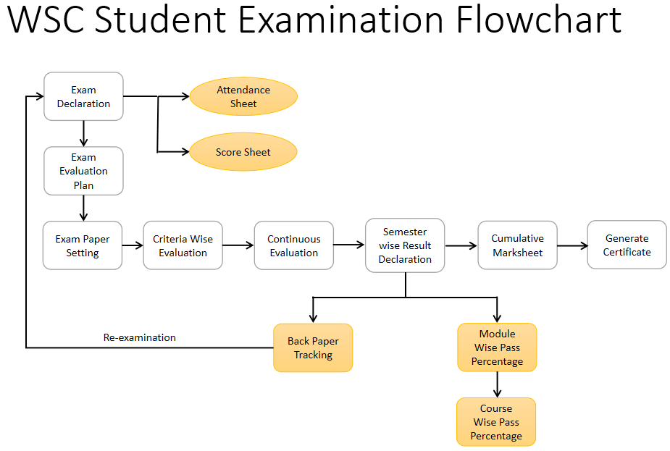

# Flowchart Description :

## Exam Declaration

The Exam Declaration will allow user to declare an exam for various programs in accordance with the ‘Academic Calendar’ template which was used during the start of each session.

## Attendance Sheet

Attendance Sheet will allow the user to maintain and mark attendance of Students present in the Examination Room.

## Score Sheet

Score sheets are used to record the marks obtained by each student in an examination. The score sheet includes the name of the student, the marks obtained in each subject, and the total marks achieved by the student.

## Exam Evaluation Plan

An Exam Evaluation Plan is a schedule to conduct the examination/assessment of a particular course for a group of students studying that course in an on-going academic term.

## Exam Paper Setting

The Exam Paper Setting is used to prepare paper setting schedules and plan for paper setters and moderators for a particular exam declaration.

## Criteria Wise Evaluation

Criteria Wise Evaluation allows to create an evaluation for a particular assessment criteria in a course for a student enrolled in that course.

## Continuous Evaluation

Continuous Evaluation is used to assess the Assessment Criteria done for a course for an individual student.

## Semester Wise Result Declaration

Semester Wise Result Declaration is used to evaluate the final assessment of a student for a particular semester.

## Back Paper Tracking

Back Paper Tracking is used to actively track and maintain history of the whole Examination process of a student who has failed in one or more module.

## Module Wise Pass Percentage

Module wise Pass Percentage is used to calculate the percentage of students who have successful passed any particular module in any specific Academic Year.

## Course Wise Pass Percentage

Course wise Pass Percentage is used to calculate the percentage of students who have successful passed any particular course in any specific Academic Year.

## Cumulative Marksheet

Cumulative Marksheet is a compilation of all the semesters with their grades in a single certificate. The Cumulative marksheet will have a list of subjects, grades obtained and CGPA (Cumulative Grade Point Average). And also details of students, such as roll number, name, age and date of birth, program enrollment.

## Generate Certificate

In the system there are multiple screens to generate different types of certificates which are issued in the name of the student after course completion. The certificates that can be generated are Leaving Certificate, Provisional Certificate, Migration certificate, etc.

# Overall Screens and Their Descriptions :

The following tables lists the pages used in Examination module :

|  |  |
| --- | --- |
| Existing Application Screen Name | Description |
| Exam Type | The Exam Type allows user to create and set values for a particular Exam Declaration which shall be beneficial to determine the type of examinations that are being conducted and can be evaluated on the basis of it. For example, an Exam Declaration can be classified as Mid Term Examination or End Term Examination. |
| Assessment Criteria | The Assessment Criteria various components of Continuous Evaluation on the basis of which evaluation shall be conducted. Also, multiple Assessment Criteria can be grouped together under Assessment Criteria Group as well as Maximum Credit can be allotted to them. It can also be linked with Exam Declaration if required. For example, Assessment Criteria can be specified as Mid Term, Practical, End Term, Quiz, Viva, etc. |
| Grading Scale | Under Grading Scale, user can define the threshold for the different grades obtained by the students, based on their scores in the assessment. For example, students obtaining a score of 90% and above would be graded as A+, students obtaining a score of 80% and above would be graded A- and so on. |
| Student Exam Block Criteria | The Student Exam Block Criteria is used to create various criteria based on which students are blocked from applying for an exam declaration. For example, Attendance and Fees can be used as Student Exam Block Criteria for an Exam Declaration. |
| Exam Declaration | The Exam Declaration will allow user to declare an exam for various programs in accordance with the ‘Academic Calendar’ template which was used during the start of each session. |
| Exam Evaluation Plan | An Exam Evaluation Plan is a schedule to conduct the examination/assessment of a particular course for a group of students studying that course in an on-going academic term. |
| Exam Paper Setting | The Exam Paper Setting is used to prepare paper setting schedules and plan for paper setters and moderators for a particular exam declaration. |
| Criteria Wise Evaluation | Criteria Wise Evaluation allows us to create an evaluation for a particular assessment criterion in a course for a student enrolled in that course. |
| Criteria Wise Evaluation Tool | Criteria Wise Evaluation Tool helps in entering marks earned by the students in a semester for a particular course and particular assessment criteria. |
| Continuous Evaluation | Continuous Evaluation is used to assess the Assessment Criteria done for a course for an individual student. |
| Continuous Evaluation Tool | Continuous Evaluation Tool is used to assess the Assessment Criteria done for a course for an individual student. |
| Final Exam Result | Final Exam Result is used to evaluate the final assessment of a student for a particular semester. |
| Final Result Declaration Tool | Final Result Declaration Tool is used to declare the final exam results for a particular group/batch of students in a semester. |
| Module Wise Pass Percentage | The module pass percentage can be used to assess the overall academic performance of each module or course during a given academic year. Module Pass Percentage is used to calculate the percentage of students who successfully completed any given module in any given Academic Year. |
| Course Wise Pass Percentage | Course Pass Percentage is used to calculate the percentage of students who successfully completed any given course during any given Academic Year. The pass percentage for each course in the institute examination is used to assess students' overall performance in that course. |
| Back Paper Tracking | Back Paper Tracking is used to actively track and maintain history of the whole Examination process of a student who has failed in one or more module. |
| Cumulative Marksheet | Cumulative Marksheet is a compilation of all the semesters with their grades in a single certificate. The Cumulative marksheet will have a list of subjects, grades obtained and CGPA (Cumulative Grade Point Average). And also details of students, such as roll number, name, age and date of birth, program enrollment. |
| Cumulative Marksheet Tool | Cumulative Marksheet is a compilation of all the semesters with their grades in a single certificate. The Cumulative marksheet will have a list of subjects, grades obtained and CGPA (Cumulative Grade Point Average). And also details of students, such as roll number, name, age and date of birth, program enrollment. |
| Leaving Certificate | Leaving Certificate is issued when the students have completed their programs. In the ERP the leaving certificate is issued when their Assessment Status is complete. It is a certificate showing a person has completed his or her time at school, sometimes requiring the passing of an exam or exams. |
| Leaving Certificate Tool | Leaving Certificate is issued when the students have completed their programs. In the ERP the leaving certificate is issued when their Assessment Status is complete. It is a certificate showing a person has completed his or her time at school, sometimes requiring the passing of an exam or exams. |
| Provisional Certificate | Provisional Certificate is issued in order to make sure that the  student is not deprived of any future opportunities in the form of a job or higher education. It helps the college administration in keeping a record of students who have passed from the university. |
| Provisional Certificate Tool | Provisional Certificate Tool is issued in order to make sure that the  student is not deprived of any future opportunities in the form of a job or higher education. It helps the college administration in keeping a record of students who have passed from the university. |
| Migration Certificate | Migration Certificate is a document issued by the concerned University or Board in which one studies. It helps in getting admission to another institution or any education board and it is issued at the completion of the course along with other necessary documents. |
| Migration Certificate Tool | Migration Certificate is a document issued by the concerned University or Board in which one studies. It helps in getting admission to another institution or any education board and it is issued at the completion of the course along with other necessary documents. |
| Conduct Certificate | A Conduct Certificate specifies the behavior of an individual during a period of time, in an official place. It is also sometimes referred to as a character certificate. A conduct certificate is given to a student when he wants to get admission in another institute or in case of transfer. |
| Conduct Certificate Tool | A Conduct Certificate specifies the behavior of an individual during a period of time, in an official place. It is also sometimes referred to as a character certificate. A conduct certificate is given to a student when he wants to get admission in another institute or in case of transfer. |

# Examination

# Masters Screen

The Examination Masters consists of transactions which would allow user to determine and set the values for the Examination Module to process easily. The transactions in Examination Master consists of:

a. Exam Type

b. Assessment Criteria

c. Grading Scale

d. Student Exam Block Criteria

Below is the complete workspace for Examination:

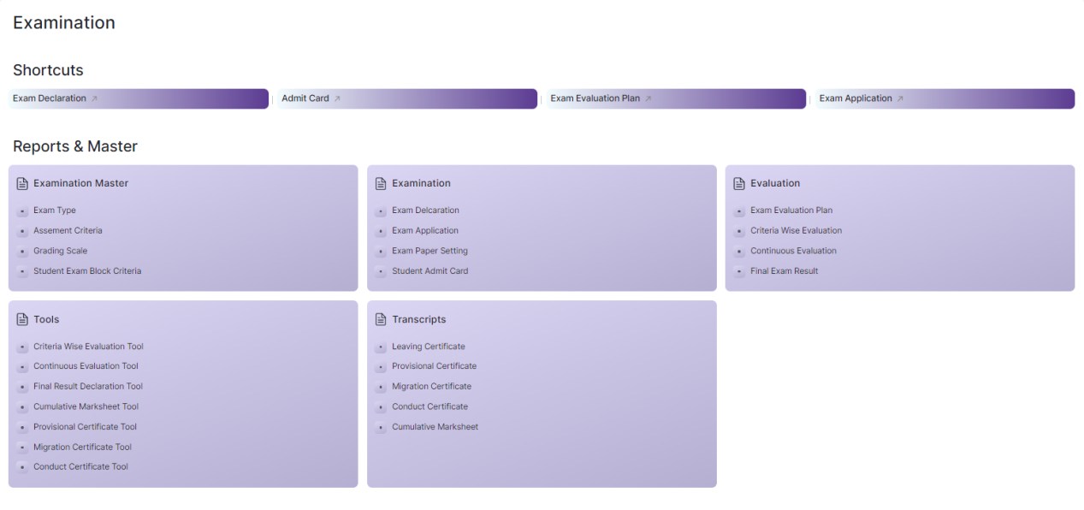

Figure 1 : Examination Home Screen

## Exam Type

|  |  |
| --- | --- |
| **Description :** | The Exam Type allows user to create and set values for a particular Exam Declaration which shall be beneficial to determine the type of examinations that are being conducted and can be evaluated on the basis of it. For example, an Exam Declaration can be classified as Mid Term Examination or End Term Examination. |
| **Navigation :** | Home > Examination > Examination Master > Exam Type |
| **Pre-requisites :** |  |
| **Existing Screen Name :** | Exam Type |
| **New Screen Name :** | NA |

### **Exam Type Screenshot:**

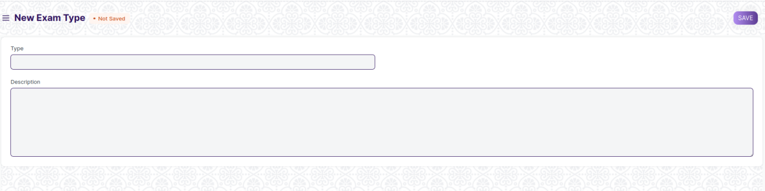

Figure 2 : Exam Type Screen

### **Exam Type Field List:**

The “Exam Type” screen shall consist of the following fields:

|  |  |  |  |  |  |
| --- | --- | --- | --- | --- | --- |
| **Field Label** | **Field Type** | **Validation/Action** | **Mandatory** | **Remarks** | **R/N/D** |
| Type | Text Field | User Input |  |  |  |
| Description | Long Text Field | User Input |  |  |  |

### **User: Roles & Permission**

The following table describes the users and their roles and permissions for the screens :

|  |  |  |  |  |  |  |  |  |
| --- | --- | --- | --- | --- | --- | --- | --- | --- |
| **Role** | **Select** | **Read** | **Write** | **Create** | **Delete** | **Submit** | **Cancel** | **Amend** |
| Admin | Yes | Yes | Yes | Yes | Yes | NA | NA | NA |
| Instructor | No | Yes | No | No | No | NA | NA | NA |
| Student | No | Yes | No | No | No | NA | NA | NA |

## **Assessment Criteria**

|  |  |
| --- | --- |
| **Description :** | The Assessment Criteria various components of Continuous Evaluation on the basis of which evaluation shall be conducted. Also, multiple Assessment Criteria can be grouped together under Assessment Criteria Group as well as Maximum Credit can be allotted to them. It can also be linked with Exam Declaration if required. For example, Assessment Criteria can be specified as Mid Term, Practical, End Term, Quiz, Viva, etc. |
| **Navigation :** | Home > Examination > Examination Master > Assessment Criteria |
| **Pre-requisites :** |  |
| **Existing Screen Name :** | Assessment Criteria |
| **New Screen Name :** | NA |

### **Assessment Criteria Screenshot:**

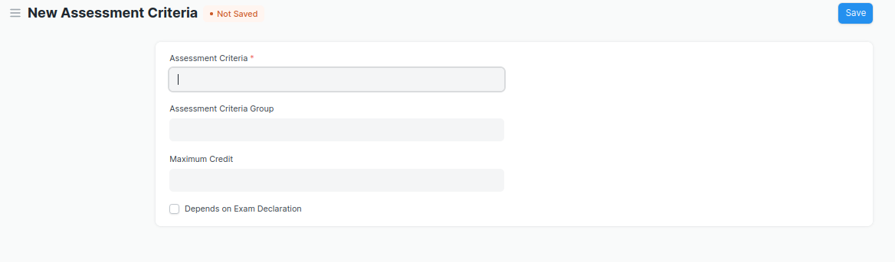

Figure 3 : Assessment Criteria Screen

### **Assessment Criteria Field List:**

The “Assessment Criteria” screen shall consist of the following fields:

|  |  |  |  |  |  |
| --- | --- | --- | --- | --- | --- |
| **Field Label** | **Field Type** | **Validation/Action** | **Mandatory** | **Remarks** | **R/N/D** |
| Assessment Criteria | Text Field | User Input | Y |  |  |
| Assessment Criteria Group | Link Field | Fetched from Assessment Criteria Group master screen |  |  |  |
| Maximum Credit | Float | User Input |  |  |  |
| Depends on Exam Declaration | Check Box | User Input |  |  |  |

### **User: Roles & Permission**

The following table describes the users and their roles and permissions for the screens :

|  |  |  |  |  |  |  |  |  |  |
| --- | --- | --- | --- | --- | --- | --- | --- | --- | --- |
| **ID** | **Role** | **Select** | **Read** | **Write** | **Create** | **Delete** | **Submit** | **Cancel** | **Amend** |
| 1 | Admin | Yes | Yes | Yes | Yes | Yes | NA | NA | NA |
| 2 | Instructor | No | Yes | No | No | No | NA | NA | NA |
| 3 | Student | No | Yes | No | No | No | NA | NA | NA |

## Grading Scale

|  |  |
| --- | --- |
| **Description :** | Under Grading Scale, user can define the threshold for the different grades obtained by the students, based on their scores in the assessment. For example, students obtaining a score of 90% and above would be graded as A+, students obtaining a score of 80% and above would be graded A- and so on. |
| **Navigation :** | Home > Examination > Examination Master > Grading Scale |
| **Pre-requisites :** |  |
| **Existing Screen Name :** | Grading Scale |
| **New Screen Name :** | NA |

### **Grading Scale Screenshot:**

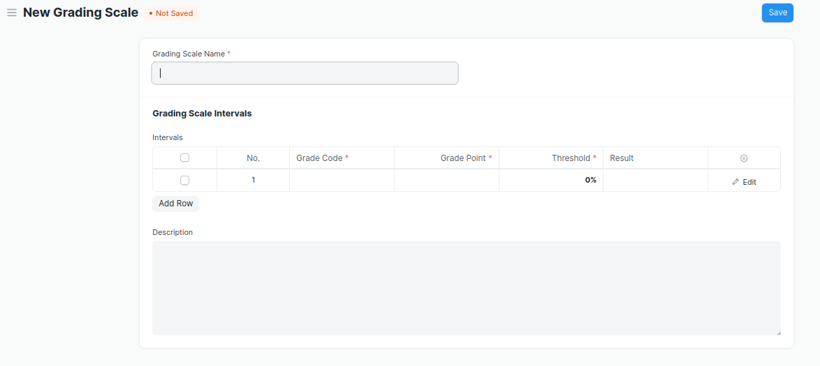

Figure 4 : Grading Scale Screen

### **Grading Scale Field List:**

The “Grading Scale” screen shall consist of the following fields:

|  |  |  |  |  |  |
| --- | --- | --- | --- | --- | --- |
| **Field Label** | **Field Type** | **Validation/Action** | **Mandatory** | **Remarks** | **R/N/D** |
| Grading Scale Name | Text Field | User Input | Y |  |  |
| **Grading Scale Interval** | Table | User Input |  | These table is describe below |  |
| Description | Long Text Field | User Input |  |  |  |

|  |  |  |  |  |  |
| --- | --- | --- | --- | --- | --- |
| **Grading Scale Interval** | | | | | |
| **Field Label** | **Field Type** | **Validation/Action** | **Mandatory** | **Remarks** | **R/N/D** |
| Grade Code | Text Field | User Input | Y |  |  |
| Grade Point | Text Field | User Input | Y |  |  |
| Threshold | Float | User Input | Y |  |  |
| Result | Drop Down | PASS  FAIL |  |  |  |
| Grade Description | Long Text Field | User Input |  |  |  |

### **User: Roles & Permission**

The following table describes the users and their roles and permissions for the screens :

|  |  |  |  |  |  |  |  |  |  |
| --- | --- | --- | --- | --- | --- | --- | --- | --- | --- |
| **ID** | **Role** | **Select** | **Read** | **Write** | **Create** | **Delete** | **Submit** | **Cancel** | **Amend** |
| 1 | Admin | Yes | Yes | Yes | Yes | Yes | Yes | Yes | Yes |
| 2 | Instructor | No | Yes | No | No | No | No | No | No |
| 3 | Student | No | Yes | No | No | No | No | No | No |

## Student Exam Block Criteria

|  |  |
| --- | --- |
| **Description :** | The Student Exam Block Criteria is used to create various criteria based on which students are blocked from applying for an exam declaration. For example, Attendance and Fees can be used as Student Exam Block Criteria for an Exam Declaration. |
| **Navigation :** | Home > Examination > Examination Master > Student Exam Block Criteria |
| **Pre-requisites :** |  |
| **Existing Screen Name :** | Student Exam Block Criteria |
| **New Screen Name :** | NA |

### **Student Exam Block Criteria Screenshot:**

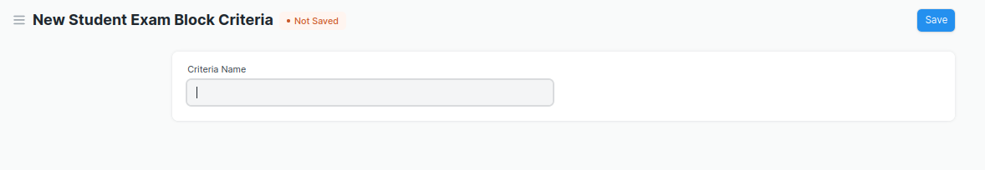

Figure 5 : Student Exam Block Criteria

### **Student Exam Block Criteria Field List:**

The “Student Exam Block Criteria” screen shall consist of the following fields:

|  |  |  |  |  |  |
| --- | --- | --- | --- | --- | --- |
| **Field Label** | **Field Type** | **Validation/Action** | **Mandatory** | **Remarks** | **R/N/D** |
| Criteria Name | Text Field | User Input |  |  |  |

### **User: Roles & Permission**

The following table describes the users and their roles and permissions for the screens :

|  |  |  |  |  |  |  |  |  |  |
| --- | --- | --- | --- | --- | --- | --- | --- | --- | --- |
| **ID** | **Role** | **Select** | **Read** | **Write** | **Create** | **Delete** | **Submit** | **Cancel** | **Amend** |
| 1 | Admin | Yes | Yes | Yes | Yes | Yes | NA | NA | NA |
| 2 | Instructor | No | Yes | No | No | No | NA | NA | NA |
| 3 | Student | No | Yes | No | No | No | NA | NA | NA |

# Transactional Screens

## Exam Declaration

|  |  |
| --- | --- |
| **Description :** | The Exam Declaration will allow user to declare an exam for various programs in accordance with the ‘Academic Calendar’ template which was used during the start of each session. |
| **Navigation :** | Home > Examination > Examination>Exam Declaration |
| **Pre-requisites :** | 1. Academic Calendar 2. Program 3. Academic Year |
| **Existing Screen Name :** | Exam Declaration |
| **New Screen Name :** | NA |

### **Exam Declaration Screenshot:**

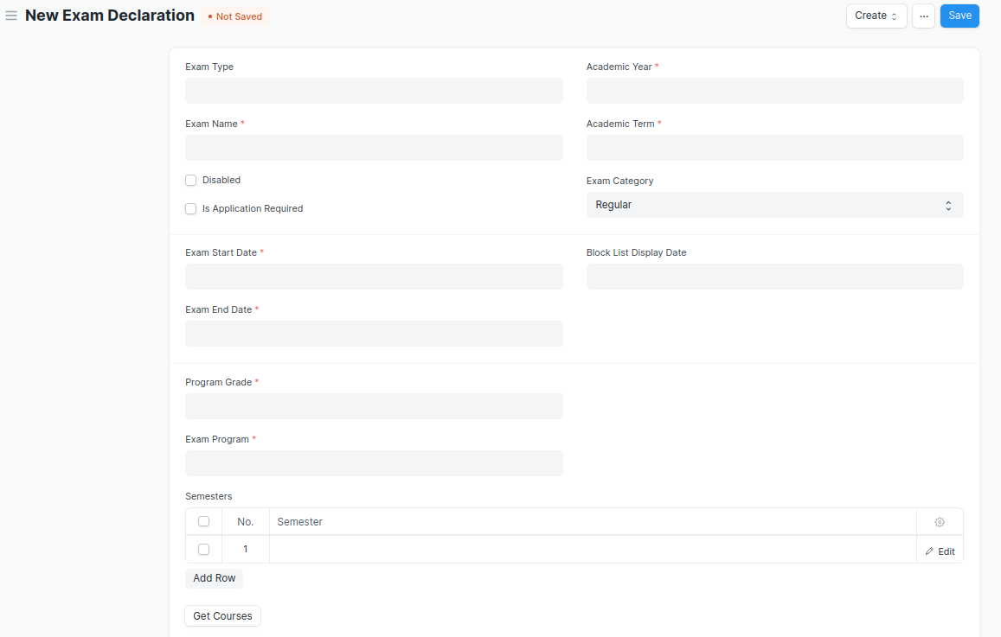

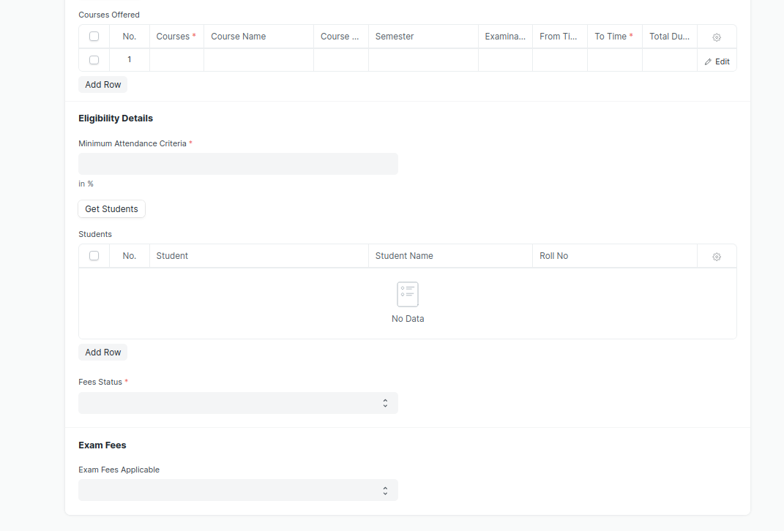

Figure 6 : Exam Declaration

* A notification or mail will be sent directly to the student after the exam declaration are announced.
* A field is required for exam Declaration to show which room and seat number will be used.
* There should be a provision in the exam declaration form for assigning an invigilator, a marker, and a checker for each module.

### **Exam Declaration Field List:**

The “Exam Declaration” screen shall consist of the following fields:

|  |  |  |  |  |  |
| --- | --- | --- | --- | --- | --- |
| **Field Label** | **Field Type** | **Validation/Action** | **Mandatory** | **Remarks** | **R/N/D** |
| Exam Type | Link Field | Fetched from Exam Type master screen |  |  |  |
| Exam Name | Text Field | User Input | Y |  |  |
| Disabled | Checkbox | User Input |  |  |  |
| Is Application Required | Checkbox | User Input |  |  |  |
| Academic Year | Link Field | Fetched from Academic Year master screen | Y |  |  |
| Academic Term | Link Field | Fetched from Academic Term master screen | Y |  |  |
| Exam Category | Drop down | Regular/Re-Exam |  |  |  |
| Application Form Start Date | Date Picker | Display and Mandatory if “Is Application Required” is checked |  |  |  |
| Application Form End Date | Date Picker | 1. Display and Mandatory if “Is Application Required” is checked 2. Should be greater than Start Date |  |  |  |
| Exam Start Date | Date Picker | User Input | Y |  |  |
| Exam End Date | Date Picker | Should be greater than Start Date | Y |  |  |
| Admit Card Issue Date | Date Picker | User Input |  |  |  |
| Block List Display Date | Date Picker | Date should be before “Exam Start Date” |  |  |  |
| Program Grade | Link | Fetched from Program Grades master screen | Y |  | 1. Course Grade |
| Exam Program | Link | Program will be fetched based from selected “Program Grade” | Y |  | (R) Exam Course |
| **Semesters** | Table | Child table: Examination Semester | Y | These table is describe below |  |
| Get Courses | Button | Courses will be fetched based on Selected “Exam Program” and “Semester” |  |  | (R) Get Modules |
| **Courses Offered** | Table | Child table: Exam Courses | Y | These table is describe below | (R) Modules Offered |
| Minimum Attendance Criteria | Float | User Input | Y |  |  |
| Get Students | Button | Students will be fetched based on selected “Exam Program”,”Semester”,”Academic Year”,”Academic Term” |  |  |  |
| Total Enrolled Student | Number | Calculated total number of Students fetched based on “Get Students” Button |  |  |  |
| **Students** | Table | Child table: Students |  | These table is describe below |  |
| Fees Status | Drop down | Full Paid/  More than 50%/  Allow all | Y |  |  |
| Exam Fees Applicable | Drop down | YES/NO |  |  |  |
| **Fee Structure** | Table | If “Exam Fees Applicable” is “Yes” then table will show |  | These table is describe below |  |

|  |  |  |  |  |  |
| --- | --- | --- | --- | --- | --- |
| **Semesters** | | | | | |
| **Field Label** | **Field Type** | **Validation/Action** | **Mandatory** | **Remarks** | **R/N/D** |
| Semester | Link Field | Fetched from Semester master screen and filtered based on Selected “Exam Program” | Y |  |  |

|  |  |  |  |  |  |
| --- | --- | --- | --- | --- | --- |
| **Courses Offered** | | | | | |
| **Field Label** | **Field Type** | **Validation/Action** | **Mandatory** | **Remarks** | **R/N/D** |
| Courses | Link Field | Auto fetch based on “Get Courses” Button | Y |  | (R) Modules |
| Course Name | Text field | Auto fetch based on “Get Courses” Button |  |  | (R) Modules Name |
| Course Code | Text field | Auto fetch based on “Get Courses” Button |  |  | (R) Modules Code |
| Semester | Link Field | Auto fetch based on “Get Courses” Button |  |  |  |
| Examination Date | Date Picker | User Input | Y |  |  |
| From Time | Time | User Input | Y |  |  |
| To Time | Time | User Input | Y |  |  |
| Total Duration (in Hours) | Time | Calculated based on “From Time” & “To Time” |  |  |  |

|  |  |  |  |  |  |
| --- | --- | --- | --- | --- | --- |
| **Students** | | | | | |
| **Field Label** | **Field Type** | **Validation/Action** | **Mandatory** | **Remarks** | **R/N/D** |
| Student | Text Field | Auto fetch based on “Get student” Button |  |  |  |
| Student Name | Text Field | Auto fetch based on “Get student” Button |  |  |  |
| Roll No | Text Field | Auto fetch based on “Get student” Button |  |  |  |
| Registration Number | Text Field | Auto fetch based on “Get student” Button |  |  |  |

|  |  |  |  |  |  |
| --- | --- | --- | --- | --- | --- |
| **Fee Structure** | | | | | |
| **Field Label** | **Field Type** | **Validation/Action** | **Mandatory** | **Remarks** | **R/N/D** |
| Student Category | Link Field | Fetched from Student Category master screen | Y |  |  |
| Fee Structure | Link Field | Fetched from Fee Structure master screen |  |  |  |
| Amount | Currency Field | Auto fetch based on “Fee Structure” |  |  |  |
| Due Date | Date Picker |  | Y |  |  |

### Exam Attendance Sheet Print Format

|  |  |
| --- | --- |
| **Description :** | On Click of Print button in Exam Declaration Screen a print format will be generated, it can also be converted into PDF format. |
| **Navigation :** |  |
| **Pre-requisites :** | Exam Declaration |
| **Existing Screen Name :** |  |
| **New Screen Name :** |  |

### Exam Attendance Sheet Print Format Screenshot:

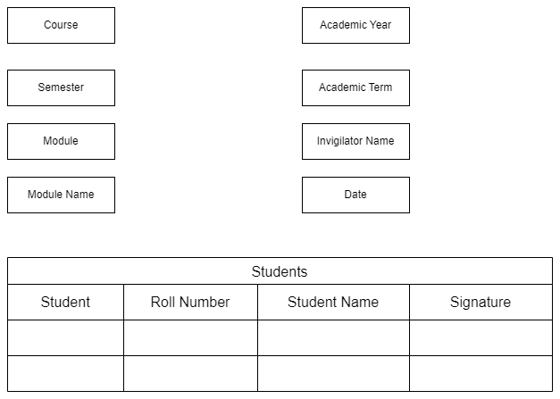

Figure 7 : Exam Attendance Sheet Print Format

### Exam Attendance Sheet Print Format Field List:

The “Exam Attendance Sheet Print Format” screen shall consist of the following fields:

|  |  |  |  |  |  |
| --- | --- | --- | --- | --- | --- |
| **Field Label** | **Field Type** | **Validation/Action** | **Mandatory** | **Remarks** | **R/N/D** |
| Course | Link Field | Auto fetch based on “Exam Declaration” | Y |  | N |
| Semester | Text Field | Auto fetch based on “Exam Declaration” |  |  | N |
| Module | Link Field | Auto fetch based on “Exam Declaration” | Y |  | N |
| Module Name | Text Field | Auto fetch based on “Exam Declaration” |  |  | N |
| Academic Year | Link Field | Auto fetch based on “Exam Declaration” |  |  | N |
| Academic Term | Link Field | Auto fetch based on “Exam Declaration” |  |  | N |
| Trainer Name | Text Field | Auto fetch based on “Exam Declaration” | Y |  | N |
| **Students** | Table | Auto fetch based on “Exam Declaration” |  |  | N |

|  |  |  |  |  |  |
| --- | --- | --- | --- | --- | --- |
| **Students** | | | | | |
| **Field Label** | **Field Type** | **Validation/Action** | **Mandatory** | **Remarks** | **R/N/D** |
| Student | Text Field | Auto fetch based on “Exam Declaration” |  |  |  |
| Student Name | Text Field | Auto fetch based on “Exam Declaration” |  |  |  |
| Roll No | Text Field | Auto fetch based on “Exam Declaration” |  |  |  |
| Registration Number | Text Field | Auto fetch based on “Exam Declaration” |  |  |  |

### Exam Score Sheet Print Format

|  |  |
| --- | --- |
| **Description :** | On Click of Print button in Exam Declaration Screen a print format will be generated, it can also be converted into PDF format. |
| **Navigation :** |  |
| **Pre-requisites :** | Exam Declaration |
| **Existing Screen Name :** |  |
| **New Screen Name :** |  |

### Exam Score Sheet Print Format Screenshot:

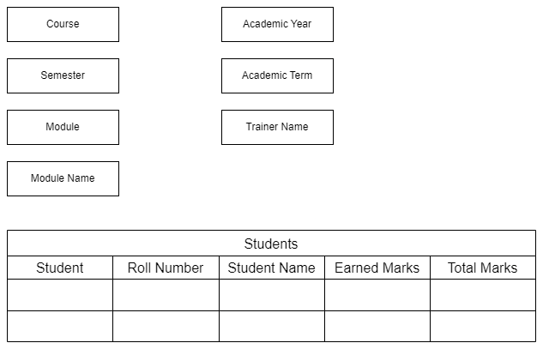

Figure 8 : Exam Score Sheet Print Format

### Exam Score Sheet Print Format Field List:

The “Exam Score Sheet Print Format” screen shall consist of the following fields:

|  |  |  |  |  |  |
| --- | --- | --- | --- | --- | --- |
| **Field Label** | **Field Type** | **Validation/Action** | **Mandatory** | **Remarks** | **R/N/D** |
| Course | Link Field | Auto fetch based on “Exam Declaration” | Y |  | N |
| Semester | Link Field | Auto fetch based on “Exam Declaration” | Y |  | N |
| Module | Link Field | Auto fetch based on “Exam Declaration” | Y |  | N |
| Module Name | Text Field | Auto fetch based on “Exam Declaration” |  |  | N |
| Academic Year | Link Field | Auto fetch based on “Exam Declaration” |  |  | N |
| Academic Term | Link Field | Auto fetch based on “Exam Declaration” |  |  | N |
| Invigilator Name | Text Field | Auto fetch based on “Exam Declaration” | Y |  | N |
| Date | Date Picker | Auto fetch based on “Exam Declaration” |  |  | N |
| **Students** | Table | Auto fetch based on “Exam Declaration” |  |  | N |

|  |  |  |  |  |  |
| --- | --- | --- | --- | --- | --- |
| **Students** | | | | | |
| **Field Label** | **Field Type** | **Validation/Action** | **Mandatory** | **Remarks** | **R/N/D** |
| Student | Text Field | Auto fetch based on “Exam Declaration” |  |  |  |
| Student Name | Text Field | Auto fetch based on “Exam Declaration” |  |  |  |
| Roll No | Text Field | Auto fetch based on “Exam Declaration” |  |  |  |
| Registration Number | Text Field | Auto fetch based on “Exam Declaration” |  |  |  |
| Earned Marks | Number | User Input |  |  |  |
| Total Marks | Number | User Input |  |  |  |

### **User: Roles & Permission**

The following table describes the users and their roles and permissions for the screens :

|  |  |  |  |  |  |  |  |  |  |
| --- | --- | --- | --- | --- | --- | --- | --- | --- | --- |
| **ID** | **Role** | **Select** | **Read** | **Write** | **Create** | **Delete** | **Submit** | **Cancel** | **Amend** |
| 1 | Admin | Yes | Yes | Yes | Yes | Yes | Yes | Yes | Yes |
| 2 | Instructor | No | Yes | No | No | No | No | No | No |
| 3 | Student | No | Yes | No | No | No | No | No | No |

## Exam Evaluation Plan

|  |  |
| --- | --- |
| **Description :** | An Exam Evaluation Plan is a schedule to conduct the examination/assessment of a particular course for a group of students studying that course in an on-going academic term. |
| **Navigation :** | Home > Examination > Evaluation > Exam Evaluation Plan |
| **Pre-requisites :** | 1. Exam Declaration 2. Instructor & Instructor Log 3. Program 4. Semester 5. Course 6. Student Group |
| **Existing Screen Name :** | Exam Evaluation Plan |
| **New Screen Name :** | NA |

### Exam Evaluation Plan Screenshot:

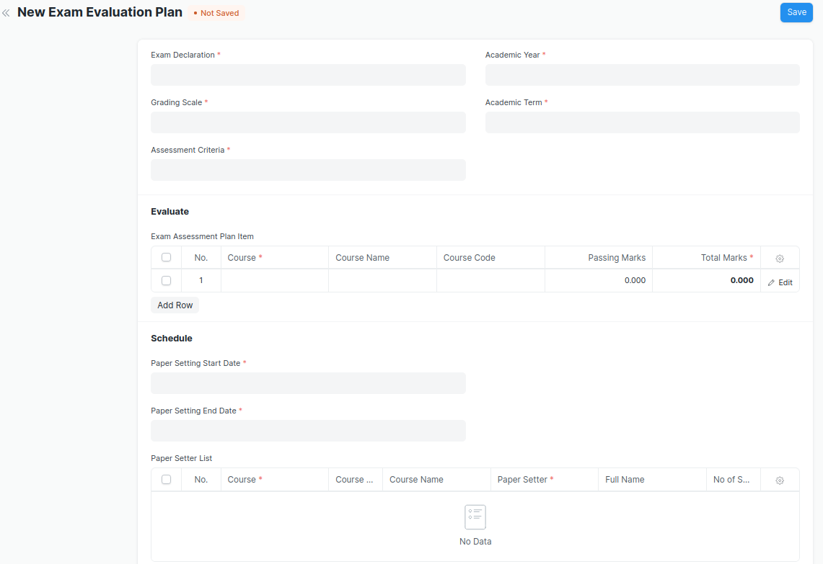

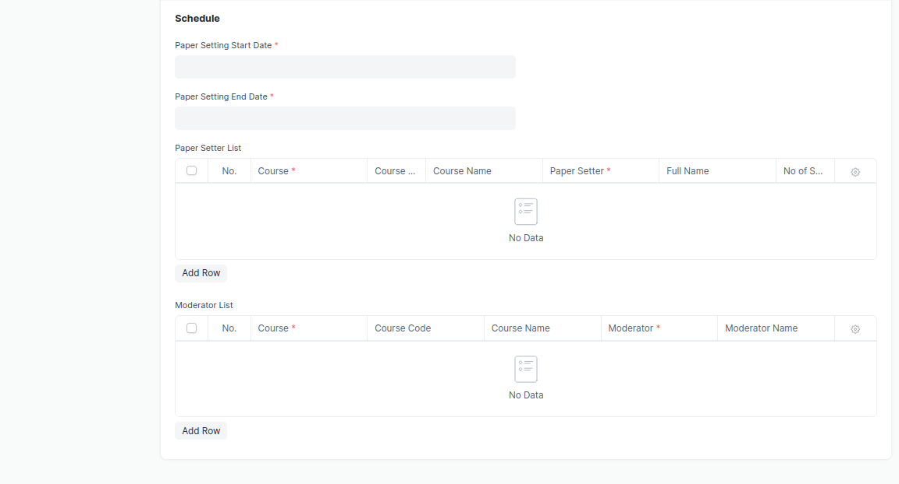

Figure 9 : Exam Evaluation Plan Screen

### Exam Evaluation Plan Field List:

The “Exam Evaluation Plan” screen shall consist of the following fields:

|  |  |  |  |  |  |
| --- | --- | --- | --- | --- | --- |
| **Field Label** | **Field Type** | **Validation/Action** | **Mandatory** | **Remarks** | **R/N/D** |
| Exam Declaration | Link Field | Fetched from Exam Declaration master screen | Y |  |  |
| Grading Scale | Link Field | Fetched from Grading Scale master screen | Y |  |  |
| Assessment Criteria | Link Field | Fetched from Assessment Criteria master screen | Y |  |  |
| Programs | Link Field | Auto fetch based on “Exam Declaration” | Y |  | (R) Course |
| Semester | Link Field | Filtered will be applied based on selected “Programs” and existing “Exam Declaration” | Y |  |  |
| Academic Year | Link Field | Auto fetch based on “Exam Declaration” | Y |  |  |
| Academic Term | Link Field | Auto fetch based on “Exam Declaration” | Y |  |  |
| **Exam Assessment Plan Item** | Table | Child Table: Course Assessment Plan Item | Y | These table is describe below |  |
| Paper Setting Start Date | Date Picker | User Input | Y |  |  |
| Paper Setting End Date | Date Picker | User Input | Y |  |  |
| **Paper Setter List** | Table | Child Table: Moderator List |  | These table is describe below |  |
| **Moderator List** | Table | Child Table: Exam Assessment Plan |  | These table is describe below |  |

|  |  |  |  |  |  |
| --- | --- | --- | --- | --- | --- |
| **Exam Assessment Plan Item** | | | | | |
| **Field Label** | **Field Type** | **Validation/Action** | **Mandatory** | **Remarks** | **R/N/D** |
| Course | Link Field | Auto fetch based on selected “Programs” & “Semester” & “Assessment Criteria” | Y |  | (R) Module |
| Course Name | Text Field | Auto fetch based on Course |  |  | (R) Module Name |
| Course Code | Text Field | Auto fetch based on Course |  |  | (R) Module Code |
| Passing Marks | Number | Auto fetch based on Course |  |  |  |
| Total Marks | Number | Auto fetch based on Course | Y |  |  |
| Total Credit | Number | Auto fetch based on Course | Y |  |  |

|  |  |  |  |  |  |
| --- | --- | --- | --- | --- | --- |
| **Paper Setter List** | | | | | |
| **Field Label** | **Field Type** | **Validation/Action** | **Mandatory** | **Remarks** | **R/N/D** |
| Course | Link Field | Only fetch those courses which belongs to the selected semester | Y |  | (R) Module |
| Course Code | Text Field | Auto fetch based on Course |  |  | (R) Module Code |
| Course Name | Text Field | Auto fetch based on Course |  |  | (R) Module Name |
| Paper Setter | Link Field | Fetched from Instructor master screen | Y |  |  |
| Full Name | Text Field | Auto fetch based on Paper Setter |  |  |  |
| No of Sets | Number |  | Y |  |  |

|  |  |  |  |  |  |  |
| --- | --- | --- | --- | --- | --- | --- |
| **Moderator List** | | | | | | |
| **Field Label** | **Field Type** | | **Validation/Action** | **Mandatory** | **Remarks** | **R/N/D** |
| Course | Link Field | Fetched those course which are present in Paper setter list | | Y |  | (R) Module |
| Course Code | Text Field | Auto fetch based on Course | |  |  | (R) Module Code |
| Course Name | Text Field | Auto fetch based on Course | |  |  | (R) Module Name |
| Moderator | Link Field | Fetched from Instructor master screen | | Y |  |  |
| Moderator Name | Text Field | Auto fetch based on Moderator | |  |  |  |

### **User: Roles & Permission**

The following table describes the users and their roles and permissions for the screens :

|  |  |  |  |  |  |  |  |  |  |
| --- | --- | --- | --- | --- | --- | --- | --- | --- | --- |
| **ID** | **Role** | **Select** | **Read** | **Write** | **Create** | **Delete** | **Submit** | **Cancel** | **Amend** |
| 1 | Admin | Yes | Yes | Yes | Yes | Yes | Yes | Yes | Yes |
| 2 | Instructor | Yes | Yes | Yes | Yes | No | Yes | No | No |
| 3 | Student | No | Yes | No | No | No | No | No | No |

## Exam Paper Setting

|  |  |
| --- | --- |
| **Description :** | The Exam Paper Setting is used to prepare paper setting schedules and plan for paper setters and moderators for a particular exam declaration. |
| **Navigation :** | Home > Examination > Examination> Exam Paper |
| **Pre-requisites :** | Exam Evaluation Plan |
| **Existing Screen Name :** | Exam Paper Settings |
| **New Screen Name :** | NA |

### Exam Paper Setting Screenshot:

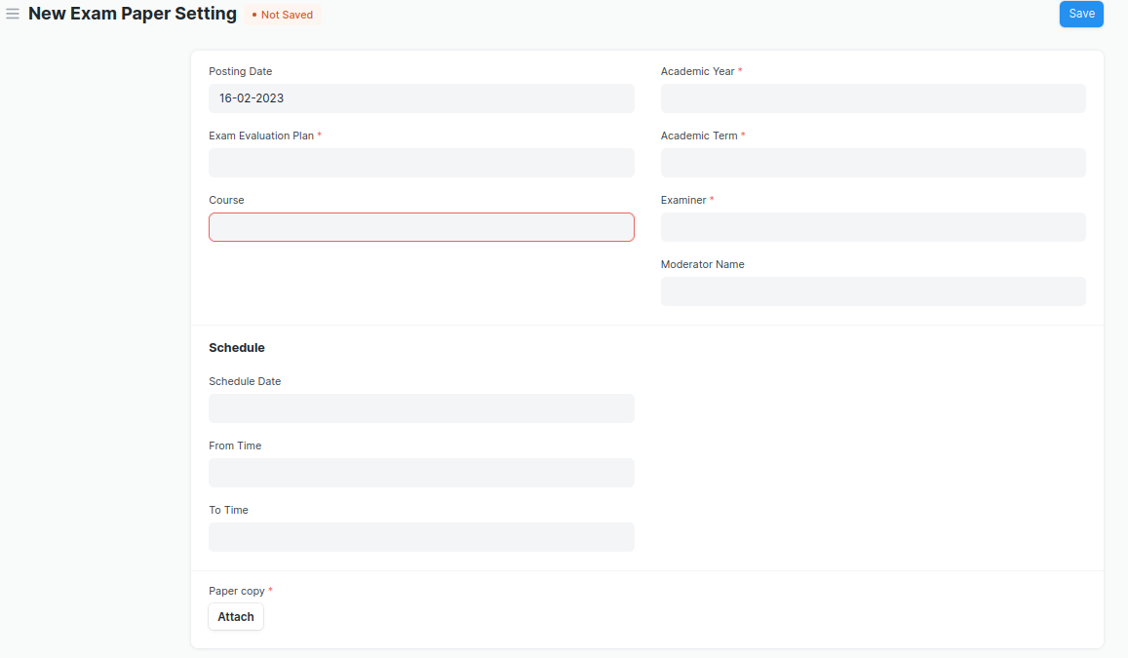

Figure 10 : Exam Paper Setting Screen

* After the paper setter moderator list is published, the paper setter will take three weeks to set the paper, and the moderator will take one week to check the paper sets.
* The paper gets reviewed by the reviewer. In case reviewer is unavailable, the paper is reviewed by Dy Director.

### Exam Paper Setting **Field List:**

The “Exam Paper Setting” screen shall consist of the following fields:

|  |  |  |  |  |  |
| --- | --- | --- | --- | --- | --- |
| **Field Label** | **Field Type** | **Validation/Action** | **Mandatory** | **Remarks** | **R/N/D** |
| Posting Date | Date | By default Today’s date is fetched |  |  |  |
| Exam Evaluation Plan | Link Field | Fetched from Exam Evaluation Plan master screen | Y |  |  |
| Programs | Link Field | Auto fetched based on “Exam Evaluation Plan” |  |  | (R) Course |
| Semester | Link Field | Auto fetched based on “Exam Evaluation Plan” |  |  |  |
| Course | Link Field | Course will be fetched based on selected “Exam Evaluation Plan” | Y |  | (R) Module |
| Course Code | Text Field | Auto fetch based on Course |  |  | (R) Module Code |
| Course Name | Text Field | Auto fetch based on Course |  |  | (R) Module Name |
| Academic Year | Link Field | Auto fetched based on “Exam Evaluation Plan” | Y |  |  |
| Academic Term | Link Field | Auto fetched based on “Exam Evaluation Plan” | Y |  |  |
| Examiner | Link Field | Examiner will be fetched based on selected “Exam Evaluation Plan” |  |  |  |
| Examiner Name | Text Field | Examiner will be fetched based on selected “Exam Evaluation Plan” |  |  |  |
| Moderator Name | Link Field | Examiner will be fetched based on selected “Exam Evaluation Plan” |  |  |  |
| Schedule Date | Date picker | User Input |  |  |  |
| From Time | Time picker | User Input |  |  |  |
| To Time | Time picker | User Input |  |  |  |
| Paper copy | Attachment Button | 1. Attach button will only visible to that instructor whose name is provided in paper setter list. 2. On attachment a dialogue box will be popup where user can attach the files, take the picture with the help camera and can link any URL. 3. If photos or images attached then the size will be maximum 200 kb. | Y |  |  |

### **User: Roles & Permission**

The following table describes the users and their roles and permissions for the screens :

|  |  |  |  |  |  |  |  |  |  |
| --- | --- | --- | --- | --- | --- | --- | --- | --- | --- |
| **ID** | **Role** | **Select** | **Read** | **Write** | **Create** | **Delete** | **Submit** | **Cancel** | **Amend** |
| 1 | Admin | Yes | Yes | Yes | Yes | Yes | Yes | Yes | Yes |
| 2 | Instructor | Yes | Yes | Yes | Yes | No | Yes | No | No |
| 3 | Student | No | Yes | No | No | No | No | No | No |

## Criteria Wise Evaluation

|  |  |
| --- | --- |
| **Description :** | Criteria Wise Evaluation allows us to create an evaluation for a particular assessment criterion in a course for a student enrolled in that course. |
| **Navigation :** | Home > Examination > Evaluation > Criteria Wise Evaluation |
| **Pre-requisites :** | 1. Exam Declaration 2. Course 3. Assessment Criteria 4. Grading Scale |
| **Existing Screen Name :** | Criteria Wise Evaluation |
| **New Screen Name :** | NA |

### Criteria Wise Evaluation Screenshot:

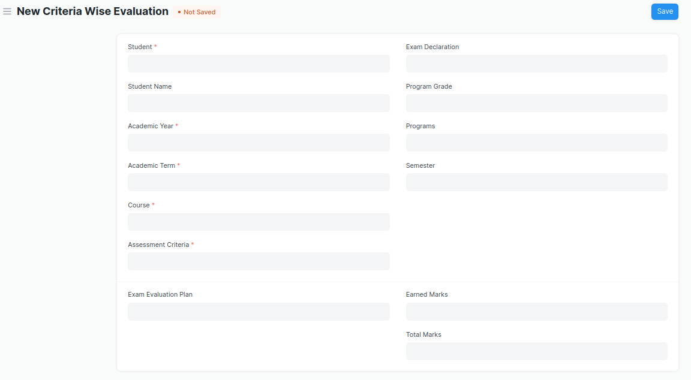

Figure 11 : Criteria Wise Evaluation Screen

* Two instructors independently evaluate a student's assessment without knowing the other's score and then come together to compare their results and determine the final grade.

### Criteria Wise Evaluation **Field List:**

The “Criteria Wise Evaluation” screen shall consist of the following fields:

|  |  |  |  |  |  |
| --- | --- | --- | --- | --- | --- |
| **Field Label** | **Field Type** | **Validation/Action** | **Mandatory** | **Remarks** | **R/N/D** |
| Student | Link Field | Fetched from student master screen | Y |  |  |
| Student Name | Text Field | Auto fetch based on Student |  |  |  |
| Roll No | Text Field | Auto fetch based on Student |  |  |  |
| Registration Number | Text Field | Auto fetch based on Student |  |  |  |
| Academic Year | Link Field | Auto fetched based on selected “Exam Declaration” | Y |  |  |
| Academic Term | Link Field | Auto fetched based on selected “Exam Declaration” | Y |  |  |
| Course | Link Field | Fetched from Course master screen, filtered will be applied Student enrolled course | Y |  | (R) Module |
| Course Name | Text Field | Auto fetch based on Course |  |  | (R) Module Name |
| Assessment Criteria | Link Field | Fetched from Assessment Criteria master screen | Y |  |  |
| Exam Declaration | Link Field | Fetched from Exam Declaration master screen |  |  |  |
| Program Grade | Link Field | Fetched from Program Grades master screen |  |  | (R) Course Grade |
| Programs | Link Field | Auto fetched based on selected “Exam Declaration” |  |  | (R) Course |
| Semester | Link Field | Fetched from Semester master screen,filtered will applied selected Programs |  |  |  |
| Exam Assessment Plan | Link Field | Fetched from Exam Assessment Plan master screen |  |  |  |
| Earned Marks | Float |  |  |  |  |
| Total Marks | Float | Auto fetched based on selected Course from Course master |  |  |  |

### **User: Roles & Permission**

The following table describes the users and their roles and permissions for the screens :

|  |  |  |  |  |  |  |  |  |  |
| --- | --- | --- | --- | --- | --- | --- | --- | --- | --- |
| **ID** | **Role** | **Select** | **Read** | **Write** | **Create** | **Delete** | **Submit** | **Cancel** | **Amend** |
| 1 | Admin | Yes | Yes | Yes | Yes | Yes | Yes | Yes | Yes |
| 2 | Instructor | Yes | Yes | Yes | Yes | No | Yes | No | No |
| 3 | Student | No | Yes | No | No | No | No | No | No |

## Criteria Wise Evaluation Tool

|  |  |
| --- | --- |
| **Description :** | Criteria Wise Evaluation Tool helps in entering marks earned by the students in a semester for  a particular course and particular assessment criteria. |
| **Navigation :** | Home > Examination > Tools > Criteria Wise Evaluation Tool |
| **Pre-requisites :** | 1. Exam Declaration 2. Course 3. Assessment Criteria 4. Grading Scale |
| **Existing Screen Name :** | Criteria Wise Evaluation Tool |
| **New Screen Name :** | NA |

### Criteria Wise Evaluation Tool Screenshot:

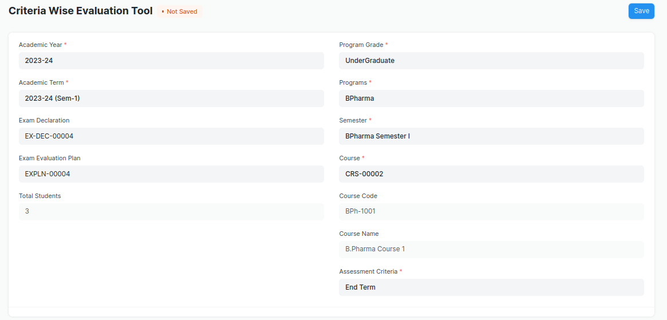

Figure 12 : Criteria Wise Evaluation Tool Screen

### Criteria Wise Evaluation **Tool Field List:**

The “Criteria Wise Evaluation Tool” screen shall consist of the following fields:

|  |  |  |  |  |  |
| --- | --- | --- | --- | --- | --- |
| **Field Label** | **Field Type** | **Validation/Action** | **Mandatory** | **Remarks** | **R/N/D** |
| Academic Year | Link Field | Fetched from Academic Year master screen | Y |  |  |
| Academic Term | Link Field | Fetched from Academic Term master screen and filter applied on the basis of Academic Year | Y |  |  |
| Exam Declaration | Link Field | Fetched from Exam Declaration master screen and filtered applied on the basis of Semester and Academic Term |  |  |  |
| Exam Assessment Plan | Link Field | Fetched from Exam Assessment Plan master screen |  |  |  |
| Total Students | Number |  |  |  |  |
| Program Grade | Link Field | Fetched from Program Grades master screen |  |  | (R)  Course Grade |
| Programs | Link Field | Fetched from Programs master screen, filtered applied on the basis of Program Grade |  |  | (R)  Courses |
| Semester | Link Field | Fetched from Program master screen and filtered applied on the basis of Programs |  |  |  |
| Course | Link Field | Fetched from Course master screen and filtered applied on the basis of Semester | Y |  | (R)  Module |
| Course Code | Text Field | Auto fetch based on Course |  |  | (R)  Module Code |
| Course Name | Text Field | Auto fetch based on Course |  |  | (R)  Module Name |
| Assessment Criteria | Link Field | Fetched from Assessment Criteria master screen | Y |  |  |
| **Student Details Data** | Table | HTML |  | These table is describe below |  |

|  |  |  |  |  |  |
| --- | --- | --- | --- | --- | --- |
| **Student Details Data** | | | | | |
| **Field Label** | **Field Type** | **Validation/Action** | **Mandatory** | **Remarks** | **R/N/D** |
| **Student** | HTML Field | Auto fetched when all the above relevant inputs given |  |  |  |
| **Student Name** | HTML Field | Auto fetched when all the above relevant inputs given |  |  |  |
| **Roll No** | HTML Field | Auto fetched when all the above relevant inputs given |  |  |  |
| **Earned Marks** | HTML Field | Auto fetched when all the above relevant inputs given |  |  |  |
| **Total Marks** | HTML Field | Auto fetched when all the above relevant inputs given |  |  |  |

### **User: Roles & Permission**

The following table describes the users and their roles and permissions for the screens :

|  |  |  |  |  |  |  |  |  |  |
| --- | --- | --- | --- | --- | --- | --- | --- | --- | --- |
| **ID** | **Role** | **Select** | **Read** | **Write** | **Create** | **Delete** | **Submit** | **Cancel** | **Amend** |
| 1 | Admin | Yes | Yes | Yes | Yes | Yes | Yes | Yes | Yes |
| 2 | Instructor | Yes | Yes | Yes | Yes | No | Yes | No | No |
| 3 | Student | No | Yes | No | No | No | No | No | No |

## Continuous Evaluation

|  |  |
| --- | --- |
| **Description :** | Continuous Evaluation is used to assess the Assessment Criteria done for a course for an individual student. |
| **Navigation :** | Home > Examination > Evaluation > Continuous Evaluation |
| **Pre-requisites :** | Criteria Wise Evaluation |
| **Existing Screen Name :** | Continuous Evaluation |
| **New Screen Name :** | NA |

### Continuous Evaluation Screenshot:

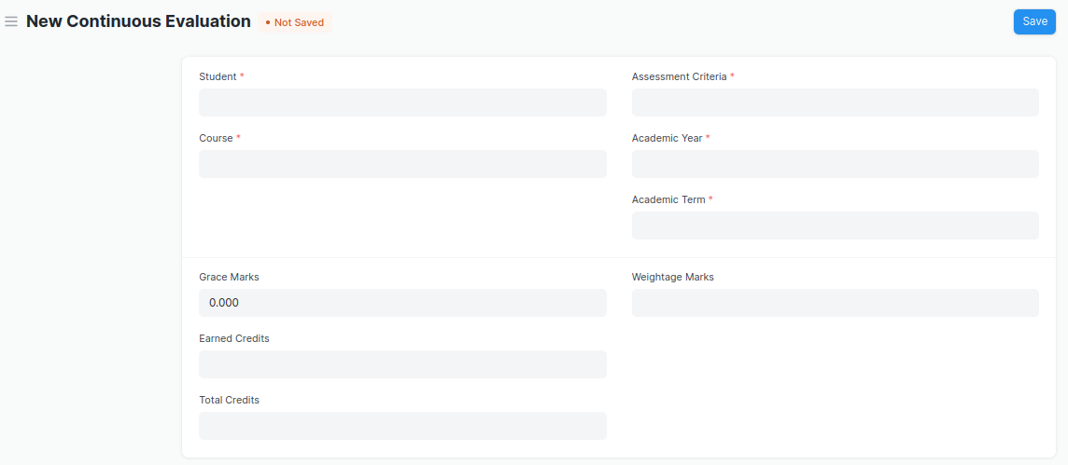

Figure 13 : Continuous Evaluation Screen

### **Continuous Evaluation Field List:**

The “Continuous Evaluation” screen shall consist of the following fields:

|  |  |  |  |  |  |
| --- | --- | --- | --- | --- | --- |
| **Field Label** | **Field Type** | **Validation/Action** | **Mandatory** | **Remarks** | **R/N/D** |
| Student | Link Field | Fetched from student master screen | Y |  |  |
| Student Name | Text Field | Auto fetch based on Student |  |  |  |
| Course | Link Field | Fetched from Course master screen | Y |  | (R) Module |
| Roll No | Text Field | Auto fetch based on Student |  |  |  |
| Registration Number | Text Field | Auto fetch based on Student |  |  |  |
| Course Code | Text Field | Auto fetch based on Course |  |  | (R) Module Code |
| Course Name | Text Field | Auto fetch based on Course |  |  | (R) Module Name |
| Assessment Criteria | Link Field | Fetched from Assessment Criteria master screen | Y |  |  |
| Academic Year | Link Field | Fetched from Academic Year master screen | Y |  |  |
| Academic Term | Link Field | Fetched from Academic Term master screen | Y |  |  |
| Get Assessments | Button | User Input |  |  |  |
| **Final Credit Item** | Table | Child Table: Final Credit Item | Y | These table is describe below |  |
| Grace Marks | Float | User Input If needed |  |  |  |
| Earned Credits | Float |  |  |  | ( D ) |
| Total Credits | Float |  |  |  | ( D ) |
| Weightage Marks | Float | Fetched from Course master screen |  |  |  |
| Final Marks | Float | Fetched from criteria wise evaluation screen respective record | Y |  |  |
| Out of Marks | Float | Fetched from Course master screen |  |  |  |

|  |  |  |  |  |  |
| --- | --- | --- | --- | --- | --- |
| **Final Credit Item** | | | | | |
| **Field Label** | **Field Type** | **Validation/Action** | **Mandatory** | **Remarks** | **R/N/D** |
| Course Assessment | Link Field | Fetched from Course Assessment master screen |  |  |  |
| Earned Marks | Float | Auto Fetched from criteria wise evaluation screen respective record |  |  |  |
| Grace Marks | Float | User Input If needed |  |  |  |
| Total Marks | Float | Auto Fetched from criteria wise evaluation screen respective record |  |  |  |

### **User: Roles & Permission**

The following table describes the users and their roles and permissions for the screens :

|  |  |  |  |  |  |  |  |  |  |
| --- | --- | --- | --- | --- | --- | --- | --- | --- | --- |
| **ID** | **Role** | **Select** | **Read** | **Write** | **Create** | **Delete** | **Submit** | **Cancel** | **Amend** |
| 1 | Admin | Yes | Yes | Yes | Yes | Yes | Yes | Yes | Yes |
| 2 | Instructor | Yes | Yes | Yes | Yes | No | Yes | No | No |
| 3 | Student | No | Yes | No | No | No | No | No | No |

## Continuous **Evaluation Tool**

|  |  |
| --- | --- |
| **Description :** | Continuous Evaluation Tool is used to assess the Assessment Criteria done for a course for an individual student. |
| **Navigation :** | Home > Examination > Tools > Continuous Evaluation Tool |
| **Pre-requisites :** | Criteria Wise Evaluation |
| **Existing Screen Name :** | Continuous Evaluation Tool |
| **New Screen Name :** | NA |

### Continuous Evaluation Tool Screenshot:

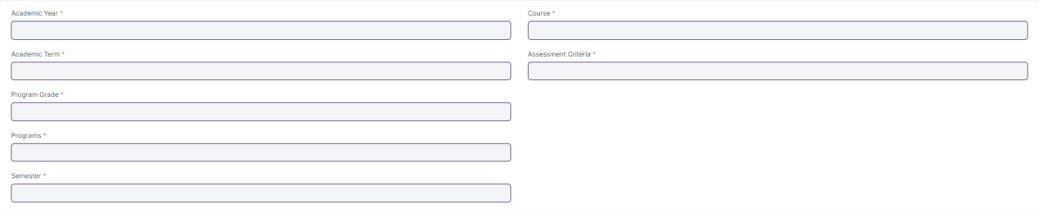

Figure 14 : Continuous Evaluation Screen

### **Continuous Evaluation Tool Field Type:**

The “Continuous Evaluation Tool” screen shall consist of the following fields:

|  |  |  |  |  |  |
| --- | --- | --- | --- | --- | --- |
| **Field Label** | **Field Type** | **Validation/Action** | **Mandatory** | **Remarks** | **R/N/D** |
| Academic Year | Link Field | Fetched from Academic Year master screen | Y |  |  |
| Academic Term | Link Field | Fetched from Academic Term master screen and filtered applied on the basis of Academic Year | Y |  |  |
| Program Grade | Link Field | Fetched from Program Grades master screen | Y |  | (R) Course Grade |
| Programs | Link Field | Fetched from Programs master screen and filtered applied on the basis of Program Grades |  |  | (R) Courses |
| Semester | Link Field | Fetched from Program master screen and filtered applied on the basis of Programs |  |  |  |
| Course | Link Field | Fetched from Course master screen and filtered applied on the basis of Semester | Y |  | (R) Module |
| Course Code | Text Field | Auto fetch based on Course |  |  | (R) Module Code |
| Course Name | Text Field | Auto fetch based on Course |  |  | (R) Module Name |
| Assessment Criteria | Link Field | Fetched from Assessment Criteria master screen | Y |  |  |
| Student Inputs | HTML |  |  |  |  |

|  |  |  |  |  |  |
| --- | --- | --- | --- | --- | --- |
| **Student Details Data** | | | | | |
| **Field Label** | **Field Type** | **Validation/Action** | **Mandatory** | **Remarks** | **R/N/D** |
| **Student** | HTML Field | Auto fetched when all the above relevant inputs given |  |  |  |
| **Student Name** | HTML Field | Auto fetched when all the above relevant inputs given |  |  |  |
| **Roll No** | HTML Field | Auto fetched when all the above relevant inputs given |  |  |  |
| **Earned Marks** | HTML Field | Auto fetched when all the above relevant inputs given |  |  |  |
| **Total Marks** | HTML Field | Auto fetched when all the above relevant inputs given |  |  |  |

### **User: Roles & Permission**

The following table describes the users and their roles and permissions for the screens :

|  |  |  |  |  |  |  |  |  |  |
| --- | --- | --- | --- | --- | --- | --- | --- | --- | --- |
| **ID** | **Role** | **Select** | **Read** | **Write** | **Create** | **Delete** | **Submit** | **Cancel** | **Amend** |
| 1 | Admin | Yes | Yes | Yes | Yes | Yes | Yes | Yes | Yes |
| 2 | Instructor | No | Yes | No | No | No | No | No | No |
| 3 | Student | No | Yes | No | No | No | No | No | No |

## Final Exam Result

|  |  |
| --- | --- |
| **Description :** | Final Exam Result is used to evaluate the final assessment of a student for a particular semester. |
| **Navigation :** | Home > Examination > Evaluation > Final Exam Result |
| **Pre-requisites :** | Continuous Evaluation |
| **Existing Screen Name :** | Final Exam Result |
| **New Screen Name :** | NA |

### Final Exam Result Screenshot:

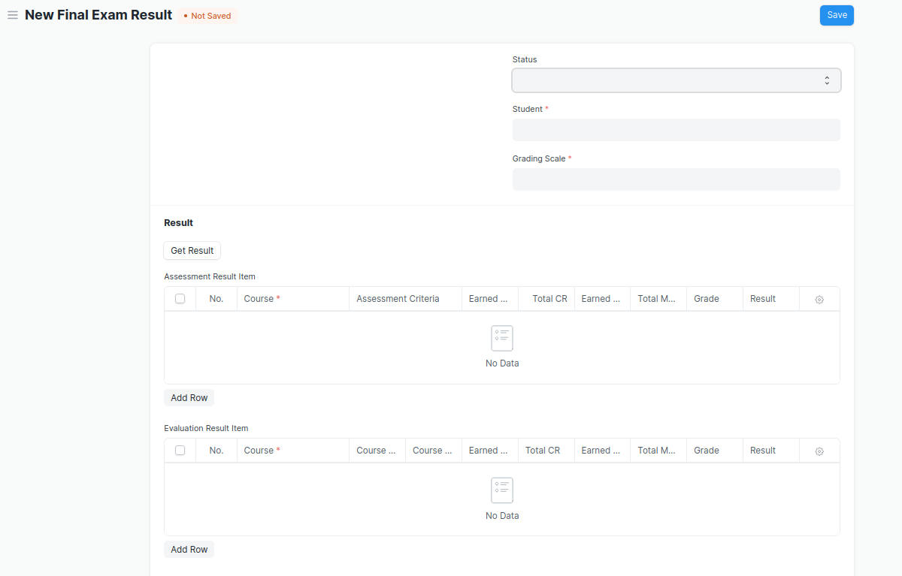

Figure 15 : Final Exam Result Screen

### Final Exam Result **Field List:**

The “Final Exam Result” screen shall consist of the following fields:

|  |  |  |  |  |  |
| --- | --- | --- | --- | --- | --- |
| **Field Label** | **Field Type** | **Validation/Action** | **Mandatory** | **Remarks** | **R/N/D** |
| Programs | Link Field | Auto fetch when Student Id is entered |  |  | (R) Courses |
| Semester | Link Field | Need to be entered manually. |  |  |  |
| Course | Link Field | Auto fetch when Student Id is entered |  |  | (R) Module |
| Academic Year | Link Field | Auto fetch when Student Id is entered |  |  |  |
| Academic Term | Link Field | Need to be entered manually |  |  |  |
| Student | Link Field | Fetched from student master screen |  |  |  |
| Student Name | Text Field | Auto fetch when Student Id is entered |  |  |  |
| Roll No | Text Field | Auto fetch when Student Id is entered |  |  |  |
| Registration Number | Text Field | Auto fetch when Student Id is entered |  |  |  |
| Grading Scale | Link Field | Fetched from Grading Scale master screen |  |  |  |
| Assessment Status | Text Field |  |  |  |  |
| Get Result | Button |  |  |  |  |
| **Assessment Result Item** | Table | After Clicking on Get Result, the **Assessment Result Item** table will auto fetch**.** |  | These table is describe below |  |
| **Evaluation Result Item** | Table | This table will visible when a record is in **Draft** Status |  | These table is describe below |  |
| Result | Text Field | Auto Calculated after saving the record |  |  |  |
| Grade | Text Field | Auto Calculated after saving the record |  |  | (N) |
| Overall Grade | Text Field | Auto Calculated after saving the record |  |  | (N) |
| Comment | Small Text Field |  |  |  |  |
| SGPA |  |  |  |  | ( D ) |
| Overall CGPA |  |  |  |  | ( D ) |

|  |  |  |  |  |  |
| --- | --- | --- | --- | --- | --- |
| **Assessment Result Item** | | | | | |
| **Field Label** | **Field Type** | **Validation/Action** | **Mandatory** | **Remarks** | **R/N/D** |
| Course | Link Field | Fetched from Course master screen | Y |  | (R) Module |
| Assessment Criteria | Link Field | Fetched from Assessment Criteria master screen |  |  |  |
| Earned CR | Float | Auto fetched on the basis of Get Result Button |  |  | ( D ) |
| Total CR | Float | Auto fetched on the basis of Get Result Button |  |  | ( D ) |
| Earned Marks | Float | Auto fetched on the basis of Get Result Button |  |  |  |
| Total Marks | Float | Auto fetched on the basis of Get Result Button |  |  |  |
| Grade | Text Field | Auto fetched on the basis of Get Result Button |  |  |  |
| Result | Drop down | Auto fetched on the basis of Get Result Button | P/F |  |  |

|  |  |  |  |  |  |
| --- | --- | --- | --- | --- | --- |
| **Evaluation Result Item (This table will visible when the record is in draft stage)** | | | | | |
| **Field Label** | **Field Type** | **Validation/Action** | **Mandatory** | **Remarks** | **R/N/D** |
| Course | Link Field | Fetched from Course master screen | Y |  | (R) Module |
| Course Code | Text Field | Auto fetch based on Course |  |  | (R) Module Code |
| Course Name | Text Field | Auto fetch based on Course |  |  | (R) Module Name |
| Earned CR | Float |  |  |  | ( D ) |
| Total CR | Text Field |  |  |  | ( D ) |
| Earned Marks | Text Field |  |  |  |  |
| Total Marks | Text Field |  |  |  |  |
| Grade | Text Field |  |  |  |  |
| Result | Drop down | P/F |  |  |  |

### **User: Roles & Permission**

The following table describes the users and their roles and permissions for the screens :

|  |  |  |  |  |  |  |  |  |
| --- | --- | --- | --- | --- | --- | --- | --- | --- |
| **Role** | **Select** | **Read** | **Write** | **Create** | **Delete** | **Submit** | **Cancel** | **Amend** |
| Admin | Yes | Yes | Yes | Yes | Yes | Yes | Yes | Yes |
| Instructor | Yes | Yes | Yes | Yes | No | Yes | No | No |
| Student | No | Yes | No | No | No | No | No | No |

## Final Result Declaration Tool

|  |  |
| --- | --- |
| **Description :** | Final Result Declaration Tool is used to declare the final exam results for a particular group/batch of students in a semester. |
| **Navigation :** | Home > Examination > Tools > Final Result Declaration Tool |
| **Pre-requisites :** | Continuous Evaluation |
| **Existing Screen Name :** | Final Result Declaration Tool |
| **New Screen Name :** | NA |

### Final Exam Result Declaration Tool Screenshot:

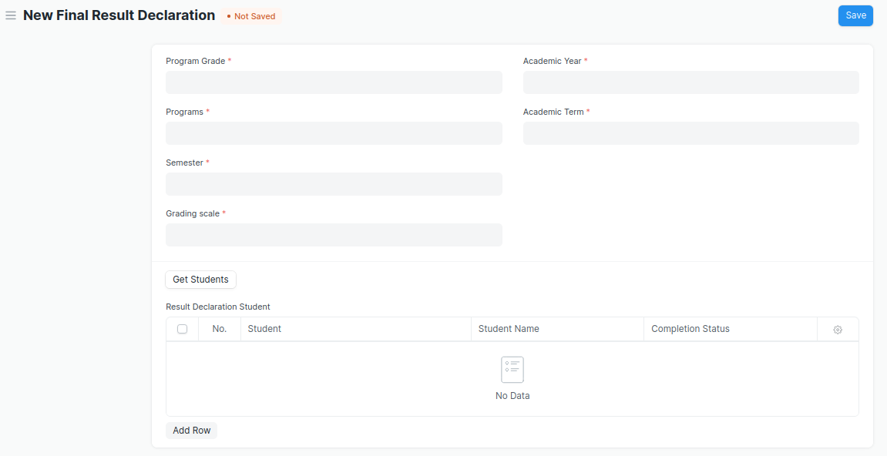

Figure 16 : Final Result Declaration Tool Screen

### Final Result Declaration Tool **Field List:**

The “Final Result Declaration Tool” screen shall consist of the following fields:

|  |  |  |  |  |  |
| --- | --- | --- | --- | --- | --- |
| **Field Label** | **Field Type** | **Validation/Action** | **Mandatory** | **Remarks** | **R/N/D** |
| Program Grade | Link Field | Fetched from Program Grades master screen | Y |  |  |
| Programs | Link Field | Fetched from Programs master screen and filtered applied on the basis of Program Grade | Y |  |  |
| Semester | Link Field | Fetched from Program master screen and filtered applied on the basis of Programs | Y |  |  |
| Grading scale | Link Field | Fetched from Grading Scale master screen | Y |  |  |
| Academic Year | Link Field | Fetched from Academic Year master screen | Y |  |  |
| Academic Term | Link Field | Fetched from Academic Term master screen and filtered applied on the basis of Academic Year | Y |  |  |
| Result Creation Status | Drop Down | In Process  Failed  Successful |  |  |  |
| Get Students | Button | User Input |  |  |  |
| Total Enrolled Student | Number | Auto created when clicked on Get Student Button |  |  |  |
| **Result Declaration Student** | Table | Child Table: Result Declaration Student |  | These table is describe below |  |

|  |  |  |  |  |  |
| --- | --- | --- | --- | --- | --- |
| **Result Declaration Student** | | | | | |
| **Field Label** | **Field Type** | **Validation/Action** | **Mandatory** | **Remarks** | **R/N/D** |
| Student | Link Field | Fetched from Student master screen |  |  |  |
| Student Name | Text Field | Auto fetch based on Student |  |  |  |
| Roll No | Text Field | Auto fetch based on Student |  |  |  |

### **User: Roles & Permission**

The following table describes the users and their roles and permissions for the screens :

|  |  |  |  |  |  |  |  |  |
| --- | --- | --- | --- | --- | --- | --- | --- | --- |
| **Role** | **Select** | **Read** | **Write** | **Create** | **Delete** | **Submit** | **Cancel** | **Amend** |
| Admin | Yes | Yes | Yes | Yes | Yes | NA | NA | NA |
| Instructor | Yes | Yes | Yes | Yes | No | NA | NA | NA |
| Student | No | Yes | No | No | No | NA | NA | NA |

## Module Wise Pass Percentage

|  |  |
| --- | --- |
| **Description :** | The module pass percentage can be used to assess the overall academic performance of each module or course during a given academic year. Module Pass Percentage is used to calculate the percentage of students who successfully completed any given module in any given Academic Year. |
| **Navigation :** |  |
| **Pre-requisites :** |  |
| **Existing Screen Name :** |  |
| **New Screen Name :** |  |

### Module Wise Pass Percentage Screenshot:

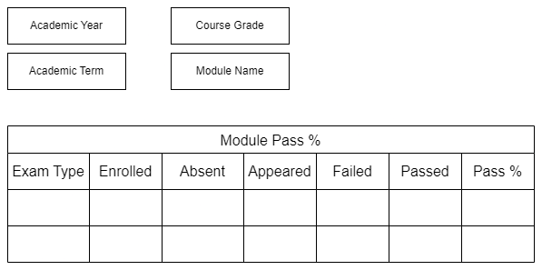

Figure 17 : Module Wise Pass Percentage Screen

### Module Wise Pass Percentage **Field List:**

The “Module Wise Pass Percentage” screen shall consist of the following fields:

|  |  |  |  |  |  |
| --- | --- | --- | --- | --- | --- |
| **Field Label** | **Field Type** | **Validation/Action** | **Mandatory** | **Remarks** | **R/N/D** |
| Academic Year | Link Field | Fetched from Academic Year master screen | Y |  | N |
| Academic Term | Link Field | Fetched from Academic Term master screen | Y |  | N |
| Course Grade | Link Field | Fetched from Program Grade master screen | Y |  | N |
| Module Name | Link Field | Fetched from Module master screen | Y |  | N |

|  |  |  |  |  |  |
| --- | --- | --- | --- | --- | --- |
| **Field Label** | **Field Type** | **Validation/Action** | **Mandatory** | **Remarks** | **R/N/D** |
| Exam Type | Link Field | Fetched from Exam Type master screen |  |  | N |
| Enrolled | Number | Calculated based on number of Student Enrolled in selected course |  |  | N |
| Absent | Number | Calculated based on Exam Attendance |  |  | N |
| Appeared | Number | Calculated based on Exam Attendance |  |  | N |
| Failed | Number |  |  |  | N |
| Pass | Number |  |  |  | N |
| Pass % | Float |  |  |  | N |

### **User: Roles & Permission**

The following table describes the users and their roles and permissions for the screens :

|  |  |  |  |  |  |  |  |  |
| --- | --- | --- | --- | --- | --- | --- | --- | --- |
| **Role** | **Select** | **Read** | **Write** | **Create** | **Delete** | **Submit** | **Cancel** | **Amend** |
| Admin | Yes | Yes | Yes | Yes | Yes | NA | NA | NA |
| Instructor | Yes | Yes | Yes | Yes | No | NA | NA | NA |
| Student | No | Yes | No | No | No | NA | NA | NA |

## Course Wise Pass Percentage

|  |  |
| --- | --- |
| **Description :** | Course Pass Percentage is used to calculate the percentage of students who successfully completed any given course during any given Academic Year. The pass percentage for each course in the institute examination is used to assess students' overall performance in that course. |
| **Navigation :** |  |
| **Pre-requisites :** |  |
| **Existing Screen Name :** |  |
| **New Screen Name :** |  |

### Course Wise Pass Percentage Screenshot:

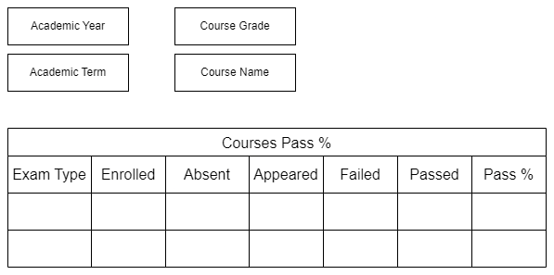

Figure 18 : Course Wise Pass Percentage Screen

### Course Wise Pass Percentage **Field List:**

The “Course Wise Pass Percentage” screen shall consist of the following fields:

|  |  |  |  |  |  |
| --- | --- | --- | --- | --- | --- |
| **Field Label** | **Field Type** | **Validation/Action** | **Mandatory** | **Remarks** | **R/N/D** |
| Academic Year | Link Field | Fetched from Academic Year master screen | Y |  | N |
| Academic Term | Link Field | Fetched from Academic Term master screen | Y |  | N |
| Course Grade | Link Field | Fetched from Program Grade master screen | Y |  | N |
| Course Name | Link Field | Fetched from Program master screen | Y |  | N |

|  |  |  |  |  |  |
| --- | --- | --- | --- | --- | --- |
| **Field Label** | **Field Type** | **Validation/Action** | **Mandatory** | **Remarks** | **R/N/D** |
| Exam Type | Link Field | Fetched from Exam Type master screen |  |  | N |
| Enrolled | Number | Calculated based on number of Student Enrolled in selected course |  |  | N |
| Absent | Number | Calculated based on Exam Attendance |  |  | N |
| Appeared | Number | Calculated based on Exam Attendance |  |  | N |
| Failed | Number |  |  |  | N |
| Pass | Number |  |  |  | N |
| Pass % | Float |  |  |  | N |

### **User: Roles & Permission**

The following table describes the users and their roles and permissions for the screens :

|  |  |  |  |  |  |  |  |  |
| --- | --- | --- | --- | --- | --- | --- | --- | --- |
| **Role** | **Select** | **Read** | **Write** | **Create** | **Delete** | **Submit** | **Cancel** | **Amend** |
| Admin | Yes | Yes | Yes | Yes | Yes | NA | NA | NA |
| Instructor | Yes | Yes | Yes | Yes | No | NA | NA | NA |
| Student | No | Yes | No | No | No | NA | NA | NA |

## Back Paper Tracking

|  |  |
| --- | --- |
| **Description :** | Back Paper Tracking is used to actively track and maintain history of the whole Examination process of a student who has failed in one or more module. |
| **Navigation :** |  |
| **Pre-requisites :** | Final Exam Result |
| **Existing Screen Name :** |  |
| **New Screen Name :** |  |

### Back Paper Tracking Screenshot:

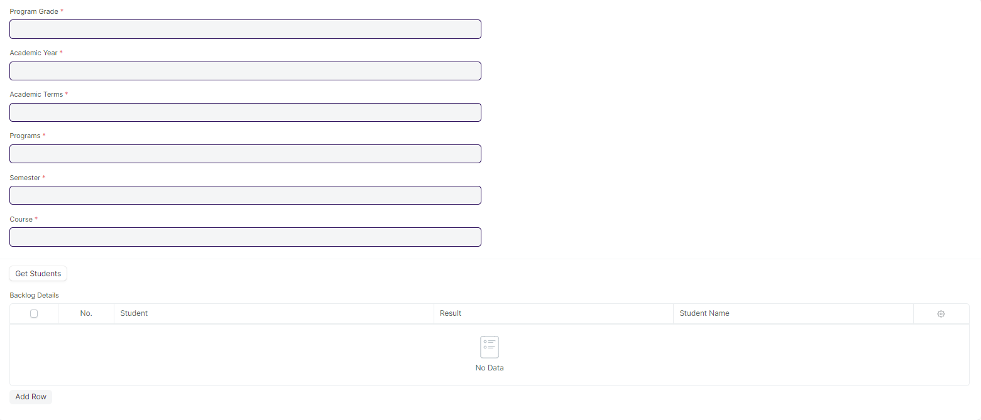

Figure 19 : Back Paper Tracking Screen

### Back Paper Tracking Screenshot **Field List:**

The “Back Paper Tracking Screenshot” screen shall consist of the following fields:

|  |  |  |  |  |  |
| --- | --- | --- | --- | --- | --- |
| **Field Label** | **Field Type** | **Validation/Action** | **Mandatory** | **Remarks** | **R/N/D** |
| Program Grade | Link Field | Fetched from Program Grade master screen | Y |  | ( R ) Course Grade |
| Academic Year | Text Field | Fetched from Academic Year master screen | Y |  |  |
| Academic Term | Link Field | Fetched from Academic Term master screen,filter will be applied based on Academic Year | Y |  |  |
| Programs | Text Field | Fetched from Programs master screen | Y |  | ( R ) Course |
| Semester | Link Field | Fetched from Semester master screen,Filtered will be applied based on selected programs | Y |  |  |
| Course | Text Field | Fetched from Course master screen | Y |  | ( R ) Module |
| Get Students | Button |  |  |  |  |
| **Backlog Details** | Table |  |  | These table is describe below |  |

|  |  |  |  |  |  |
| --- | --- | --- | --- | --- | --- |
| Students | | | | | |
| **Field Label** | **Field Type** | **Validation/Action** | **Mandatory** | **Remarks** | **R/N/D** |
| Student | Link Field | Failed student will be fetched clicking on Get Student Button |  |  |  |
| Student Name | Text Field | Auto fetch based on Student |  |  |  |
| Result | Text Field | Fail |  |  |  |

### **User: Roles & Permission**

The following table describes the users and their roles and permissions for the screens :

|  |  |  |  |  |  |  |  |  |
| --- | --- | --- | --- | --- | --- | --- | --- | --- |
| **Role** | **Select** | **Read** | **Write** | **Create** | **Delete** | **Submit** | **Cancel** | **Amend** |
| Admin | Yes | Yes | Yes | Yes | Yes | NA | NA | NA |
| Instructor | Yes | Yes | Yes | Yes | No | NA | NA | NA |
| Student | No | Yes | No | No | No | NA | NA | NA |

## Cumulative Marksheet

|  |  |
| --- | --- |
| **Description :** | Cumulative Marksheet is a compilation of all the semesters with their grades in a single certificate. The Cumulative marksheet will have a list of subjects, grades obtained and CGPA (Cumulative Grade Point Average). And also details of students, such as roll number, name, age and date of birth, program enrollment. |
| **Navigation :** | Home > Examination > Transcripts > Cumulative Marksheet |
| **Pre-requisites :** | Final Exam Result |
| **Existing Screen Name :** | Cumulative Marksheet |
| **New Screen Name :** | NA |

### **Cumulative Marksheet Screenshot:**

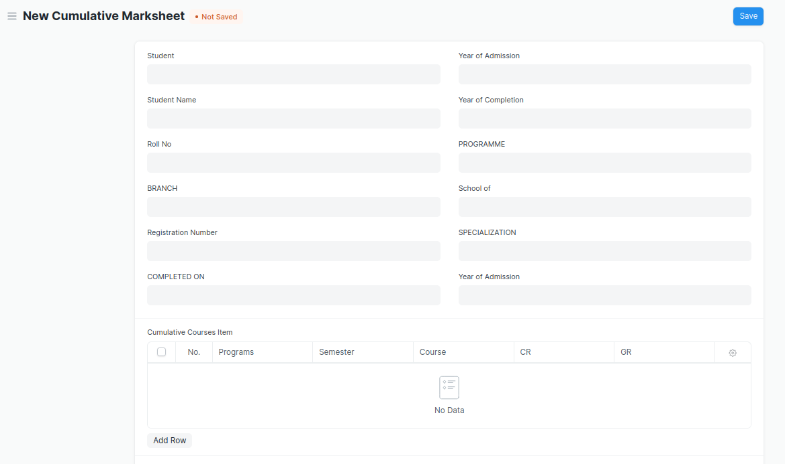

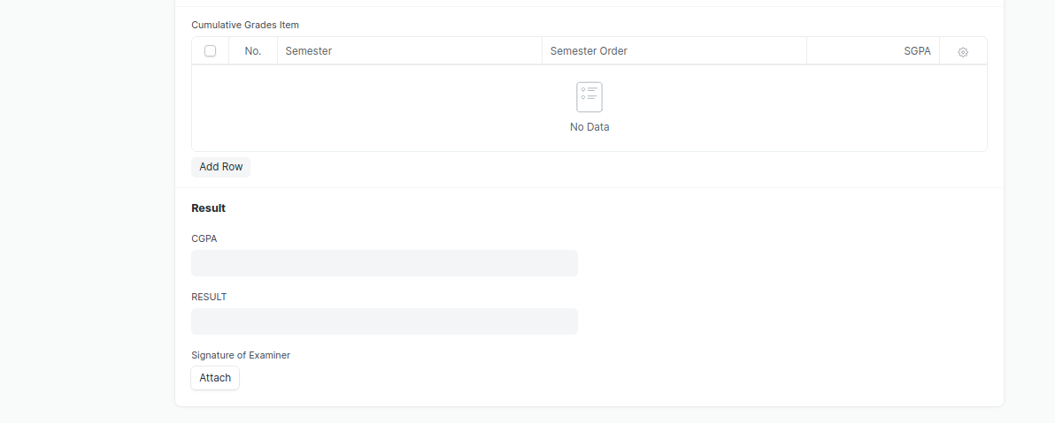

Figure 20 : Cumulative Marksheet Screen

* Remove/Hide the CGPA, SGPA, and Credit features from the Cumulative Mark sheet and display the percentage and grade instead.

### **Cumulative Marksheet Field List:**

The “Cumulative Marksheet” screen shall consist of the following fields:

|  |  |  |  |  |  |
| --- | --- | --- | --- | --- | --- |
| **Field Label** | **Field Type** | **Validation/Action** | **Mandatory** | **Remarks** | **R/N/D** |
| Student | Link Field | Fetched from Student master screen |  |  |  |
| Student Name | Text Field | Auto fetch based on Student |  |  |  |
| Roll No | Text Field | Auto fetch based on Student |  |  |  |
| BRANCH | Text Field |  |  |  |  |
| Registration Number | Text Field | Auto fetch based on Student |  |  |  |
| COMPLETED ON | Text Field |  |  |  |  |
| Year of Admission | Link Field | Fetched from Academic Year master screen |  |  |  |
| Year of Completion | Link Field | Linked with Academic Year master screen |  |  |  |
| PROGRAMME | Link Field | Fetched from Programs master screen |  |  |  |
| School of | Text Field |  |  |  |  |
| Year of Admission | Text Field |  |  |  |  |
| **Cumulative Courses Item** | Table | Child Table: Cumulative Courses Item |  | These table is describe below |  |
| **Cumulative Grades Item** | Table | Child Table: Cumulative Grades Item |  | These table is describe below |  |
| Overall Grade | Float |  |  |  |  |
| RESULT | Text Field | User Input |  |  |  |
| Signature of Examiner | Attach image | 1. On attachment a dialogue box will be popup where user can attach the files, take the picture with the help camera and can link any URL. 2. If photos or images attached then the size will be maximum 200 kb |  |  |  |

|  |  |  |  |  |  |
| --- | --- | --- | --- | --- | --- |
| **Cumulative Courses Item** | | | | | |
| **Field Label** | **Field Type** | **Validation/Action** | **Mandatory** | **Remarks** | **R/N/D** |
| Programs | Link Field | Fetched from Programs master screen |  |  |  |
| Semester | Link Field | Fetched from Program master screen |  |  |  |
| Course | Link Field | Fetched from Course master screen |  |  | (R) Module |
| Course Code | Text Field | Auto fetch based on Course |  |  | (R) Module Code |
| Course Name | Text Field | Auto fetch based on Course |  |  | (R) Module Name |
| CR | Text Field |  |  |  | ( D ) |
| GR | Text Field |  |  |  | ( D ) |

|  |  |  |  |  |  |
| --- | --- | --- | --- | --- | --- |
| **Cumulative Grades Item** | | | | | |
| **Field Label** | **Field Type** | **Validation/Action** | **Mandatory** | **Remarks** | **R/N/D** |
| Semester | Link Field | Fetched from Program master screen |  |  |  |
| Semester Order | Drop down | 1ST SEM  2ND SEM  3RD SEM  4TH SEM  5TH SEM  6TH SEM  7TH SEM  8TH SEM  9TH SEM  10TH SEM |  |  |  |
| Grade | Text Field |  |  |  | (D) These field will be deleted |

### **User: Roles & Permission**

The following table describes the users and their roles and permissions for the screens :

|  |  |  |  |  |  |  |  |  |
| --- | --- | --- | --- | --- | --- | --- | --- | --- |
| **Role** | **Select** | **Read** | **Write** | **Create** | **Delete** | **Submit** | **Cancel** | **Amend** |
| Admin | Yes | Yes | Yes | Yes | Yes | NA | NA | NA |
| Instructor | Yes | Yes | Yes | Yes | No | NA | NA | NA |
| Student | No | Yes | No | No | No | NA | NA | NA |

## Cumulative Marksheet Tool

|  |  |
| --- | --- |
| **Description :** | Cumulative Marksheet Tool is a compilation of all the semesters with their grades in a single certificate. The Cumulative marksheet will have a list of subjects, grades obtained and CGPA (Cumulative Grade Point Average). And also details of students, such as roll number, name, age and date of birth, program enrollment. |
| **Navigation :** | Home > Examination > Tools > Cumulative Marksheet Tool |
| **Pre-requisites :** | Final Exam Result |
| **Existing Screen Name :** | Cumulative Marksheet |
| **New Screen Name :** | NA |

### **Cumulative Marksheet Tool Screenshot:**

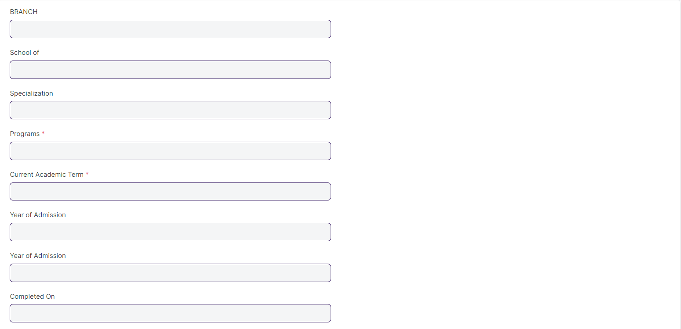

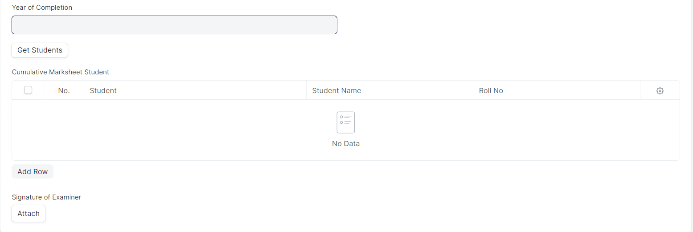

Figure 21 : Cumulative Marksheet Tool

* Remove/Hide the CGPA, SGPA, and Credit features from the Cumulative Mark sheet and display the percentage and grade instead.

### Cumulative Marksheet Tool **Field List:**

The “Cumulative Marksheet Tool” screen shall consist of the following fields:

|  |  |  |  |  |  |
| --- | --- | --- | --- | --- | --- |
| **Field Label** | **Field Type** | **Validation/Action** | **Mandatory** | **Remarks** | **R/N/D** |
| BRANCH | Text Field |  |  |  |  |
| School of | Text Field |  |  |  |  |
| Specialization | Text Field |  |  |  |  |
| Programs | Link Field | Fetched from Programs master screen | Y |  |  |
| Current Academic Term | Link Field | Fetched from Academic Term master screen | Y |  |  |
| Year of Admission | Link Field | Fetched from Academic Year master screen |  |  |  |
| COMPLETED ON | Text Field |  |  |  |  |
| Year of Completion | Link Field | Fetched from Academic Year master screen |  |  |  |
| Result Creation Status | Dropdown | In Process/Failed/  Successful |  |  |  |
| Get Students | Button | On click this button Student will fetch based on Programs & Academic Term in the Cumulative Marksheet Student |  |  |  |
| Total Students for Marksheet | Number |  |  |  |  |
| **Cumulative Marksheet Student** | Table | Child Table: Cumulative Marksheet Student |  | These table is describe below |  |
| Signature of Examiner | Attach image | 1. On attachment a dialogue box will be popup where user can attach the files, take the picture with the help camera and can link any URL.   If photos or images attached then the size will be maximum 200 kb |  |  |  |

|  |  |  |  |  |  |
| --- | --- | --- | --- | --- | --- |
| **Cumulative Marksheet Student** | | | | | |
| **Field Label** | **Field Type** | **Validation/Action** | **Mandatory** | **Remarks** | **R/N/D** |
| Student | Link Field | Fetched from “Get Students” Button |  |  |  |
| Student Name | Text Field | Auto fetch based on Student |  |  |  |
| Roll No | Text Field | Auto fetch based on Student |  |  |  |
| Registration Number | Text Field | Auto fetch based on Student |  |  |  |

### **User: Roles & Permission**

The following table describes the users and their roles and permissions for the screens :

|  |  |  |  |  |  |  |  |  |
| --- | --- | --- | --- | --- | --- | --- | --- | --- |
| **Role** | **Select** | **Read** | **Write** | **Create** | **Delete** | **Submit** | **Cancel** | **Amend** |
| Admin | Yes | Yes | Yes | Yes | Yes | NA | NA | NA |
| Instructor | Yes | Yes | Yes | Yes | No | NA | NA | NA |
| Student | No | Yes | No | No | No | NA | NA | NA |

## Leaving Certificate

|  |  |
| --- | --- |
| **Description :** | Leaving Certificate is issued when the students have completed their programs. In the ERP the leaving certificate is issued when their Assessment Status is complete. It is a certificate showing a person has completed his or her time at school, sometimes requiring the passing of an exam or exams. |
| **Navigation :** | Home > Examination > Transcripts > Leaving Certificate |
| **Pre-requisites :** | The Student should have completed his/her respective program. |
| **Existing Screen Name :** | Leaving Certificate |
| **New Screen Name :** | NA |

### Leaving Certificate **Screenshot:**

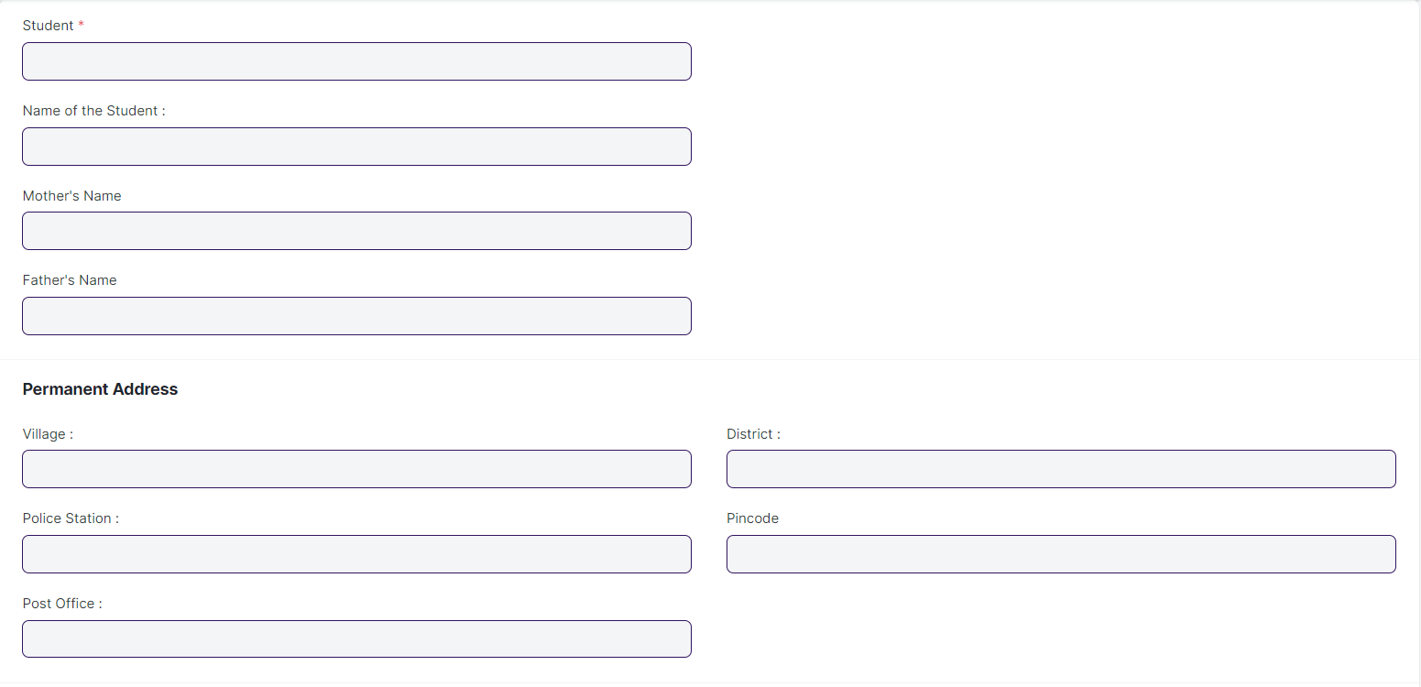

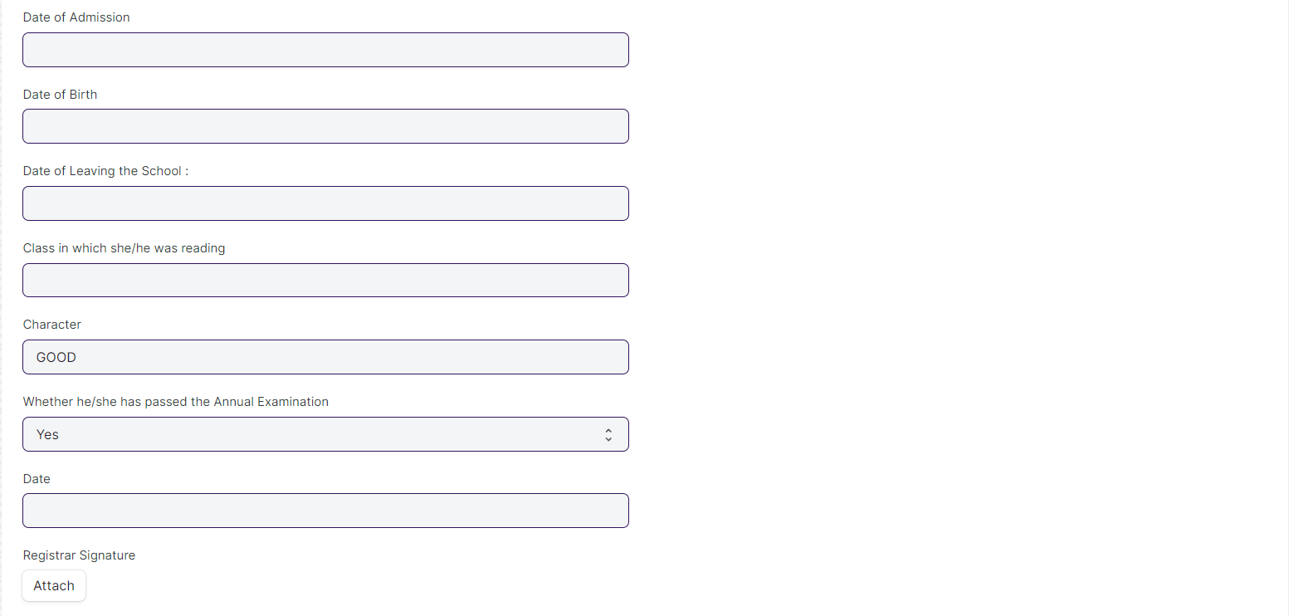

Figure 22 : Leaving Certificate Screen

### Leaving Certificate **Field List:**

The “Leaving Certificate” screen shall consist of the following fields:

|  |  |  |  |  |  |
| --- | --- | --- | --- | --- | --- |
| **Field Label** | **Field Type** | **Validation/Action** | **Mandatory** | **Remarks** | **R/N/D** |
| Student | Link Field | Fetched from Student master screen | Y |  |  |
| Name of the Student : | Text Field | Auto fetch based on Student |  |  |  |
| Roll No | Text Field | Auto fetch based on Student |  |  |  |
| Mother's Name | Text Field | Auto fetch based on Student |  |  |  |
| Father's Name | Text Field | Auto fetch based on Student |  |  |  |
| Village : | Text Field | Auto fetch based on Student |  |  |  |
| Police Station : | Text Field | Auto fetch based on Student |  |  |  |
| Post Office : | Text Field | Auto fetch based on Student |  |  |  |
| District : | Text Field | Auto fetch based on Student |  |  |  |
| Pincode | Text Field | Auto fetch based on Student |  |  |  |
| Date of Admission | Text Field |  |  |  |  |
| Date of Birth | Date | Auto fetch based on Student |  |  |  |
| Date of Leaving the School : | Text Field |  |  |  |  |
| Class in which she/he was reading | Link Field | Links to Program Screen |  |  |  |
| Character | Text Field |  |  |  |  |
| Whether he/she has passed the Annual Examination | Drop Down | Yes  No |  |  |  |
| Date | Date Picker | User Input |  |  |  |
| Registrar Signature | Attach Image | 1. On attachment a dialogue box will be popup where user can attach the files, take the picture with the help camera and can link any URL. 2. If photos or images attached then the size will be maximum 200 kb. |  |  |  |

### **User: Roles & Permission**

The following table describes the users and their roles and permissions for the screens :

|  |  |  |  |  |  |  |  |  |
| --- | --- | --- | --- | --- | --- | --- | --- | --- |
| **Role** | **Select** | **Read** | **Write** | **Create** | **Delete** | **Submit** | **Cancel** | **Amend** |
| Admin | Yes | Yes | Yes | Yes | Yes | NA | NA | NA |
| Instructor | No | Yes | No | No | No | NA | NA | NA |
| Student | No | Yes | No | No | No | NA | NA | NA |

## Leaving Certificate Tool

|  |  |
| --- | --- |
| **Description :** | Leaving Certificate is issued when the students have completed their programs. In the ERP the leaving certificate is issued when their Assessment Status is complete. It is a certificate showing a person has completed his or her time at school, sometimes requiring the passing of an exam or exams. |
| **Navigation :** | Home > Examination > Tools > Leaving Certificate Tool |
| **Pre-requisites :** |  |
| **Existing Screen Name :** | Leaving Certificate Tool |
| **New Screen Name :** | NA |

### Leaving Certificate **Tool Screenshot:**

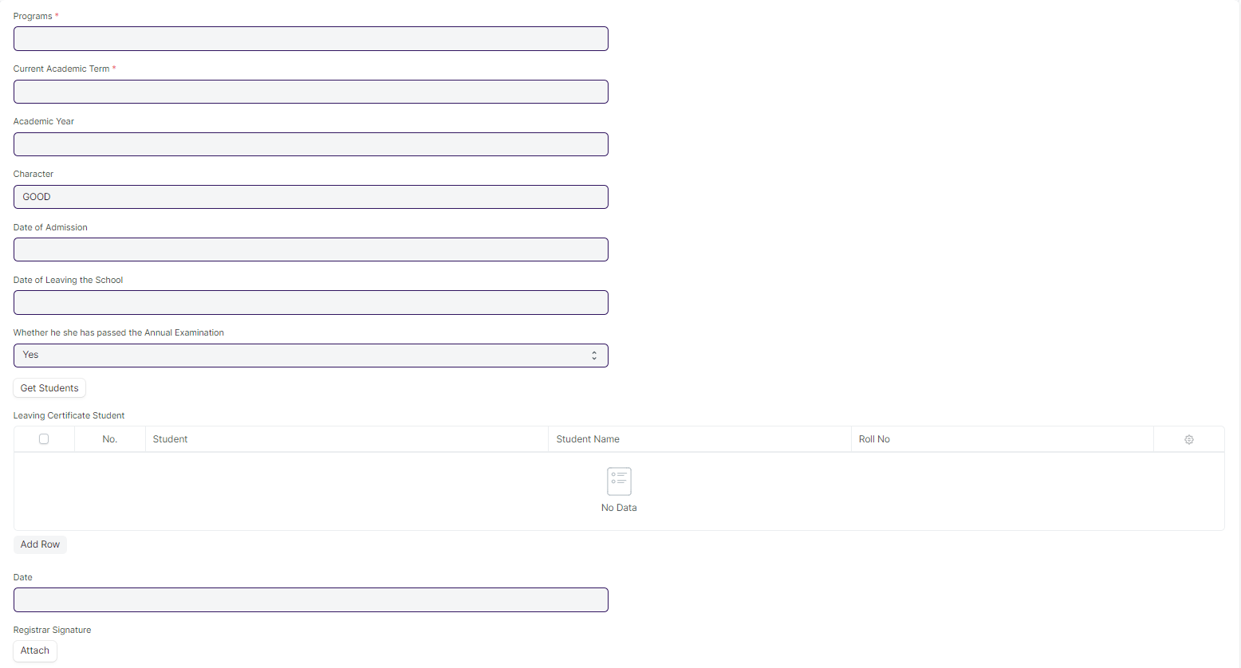

Figure 23 : Leaving Certificate Tool

### Leaving Certificate **Field List:**

The “Leaving Certificate Tool” screen shall consist of the following fields:

|  |  |  |  |  |  |
| --- | --- | --- | --- | --- | --- |
| **Field Label** | **Field Type** | **Validation/Action** | **Mandatory** | **Remarks** | **R/N/D** |
| Programs | Link Field | Fetched from Programs master screen | Y |  | (R) Course |
| Current Academic Term | Link Field | Fetched from Academic Term master screen |  |  |  |
| Academic Year | Link Field | Fetched from Academic Year master screen |  |  |  |
| Academic Year Start | Date |  |  |  |  |
| Character | Text Field | Default:GOOD |  |  |  |
| Date of Admission | Text Field |  |  |  |  |
| Date of Leaving the School | Text Field |  |  |  |  |
| Whether he she has passed the Annual Examination | Dropdown | Yes/No |  |  |  |
| Academic Year End | Date | Auto fetch based on Student |  |  |  |
| Certificate Creation Status | Dropdown | Auto fetch based on Student |  |  |  |
| Get Students | Button |  |  |  |  |
| Total Students for Certificate | Number | Auto inputted when Get Students button clicked |  |  |  |
| **Leaving Certificate Student** | Table | Description of this table is given below |  |  |  |
| Date | Date Picker | User Input |  |  |  |
| Registrar Signature | Attach Image | 1. On attachment a dialogue box will be popup where user can attach the files, take the picture with the help camera and can link any URL. 2. If photos or images attached then the size will be maximum 200 kb. |  |  |  |

|  |  |  |  |  |  |  |  |  |  |  |  |
| --- | --- | --- | --- | --- | --- | --- | --- | --- | --- | --- | --- |
| **Leaving Certificate Student** | | | | | | | | | | | |
| **Field Label** | **Field Type** | | **Validation/Action** | | **Mandatory** | | **Remarks** | | **R/N/D** | |
| Student | | Link Field | | Fetched from Get Students Button | |  | |  | |  | |
| Student Name | | Text Field | | Auto fetch based on Student | |  | |  | |  | |
| Roll No | | Text Field | | Auto fetch based on Student | |  | |  | |  | |
| Registration Number | | Text Field | | Auto fetch based on Student | |  | |  | |  | |

### **User: Roles & Permission**

The following table describes the users and their roles and permissions for the screens :

|  |  |  |  |  |  |  |  |  |
| --- | --- | --- | --- | --- | --- | --- | --- | --- |
| **Role** | **Select** | **Read** | **Write** | **Create** | **Delete** | **Submit** | **Cancel** | **Amend** |
| Admin | Yes | Yes | Yes | Yes | Yes | NA | NA | NA |
| Instructor | No | Yes | No | No | No | NA | NA | NA |
| Student | No | Yes | No | No | No | NA | NA | NA |

## Provisional Certificate

|  |  |
| --- | --- |
| **Description :** | Provisional Certificate is issued in order to make sure that the  student is not deprived of any future opportunities in the form of a job or higher education. It helps the college administration in keeping a record of students who have passed from the university. |
| **Navigation :** | Home > Examination > Transcripts >Provisional Certificate |
| **Pre-requisites :** |  |
| **Existing Screen Name :** | Provisional Certificate |
| **New Screen Name :** | NA |

### **Provisional Certificate Screenshot:**

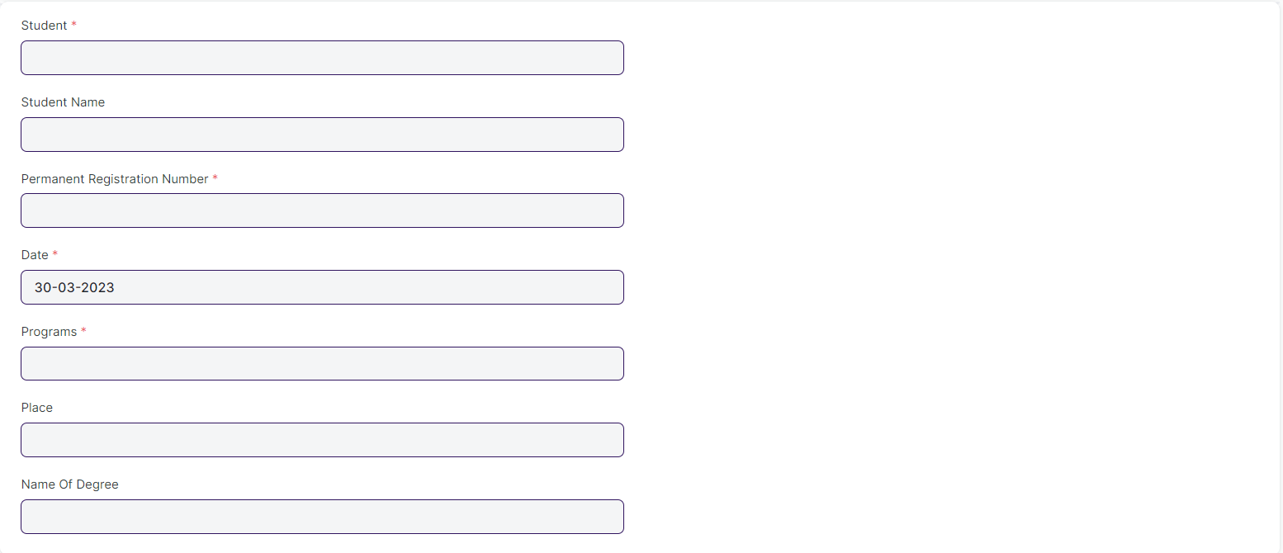

Figure 24 : Provisional Certificate

### Provisional Certificate **Field List:**

The “Provisional Certificate” screen shall consist of the following fields:

|  |  |  |  |  |  |
| --- | --- | --- | --- | --- | --- |
| **Field Label** | **Field Type** | **Validation/Action** | **Mandatory** | **Remarks** | **R/N/D** |
| Student | Link Field | Fetched from Student master screen | Y |  |  |
| Student Name | Text Field | Auto fetch based on Student |  |  |  |
| Roll No | Text Field | Auto fetch based on Student |  |  |  |
| Permanent Registration Number | Text Field | Auto fetch based on Student | Y |  |  |
| Date | Date | Today’s date is fetched | Y |  |  |
| Programs | Link Field | Fetched from Programs master screen | Y |  |  |
| Place | Text Field |  |  |  |  |
| Name Of Degree | Text Field |  |  |  |  |

### **User: Roles & Permission**

The following table describes the users and their roles and permissions for the screens :

|  |  |  |  |  |  |  |  |  |
| --- | --- | --- | --- | --- | --- | --- | --- | --- |
| **Role** | **Select** | **Read** | **Write** | **Create** | **Delete** | **Submit** | **Cancel** | **Amend** |
| Admin | Yes | Yes | Yes | Yes | Yes | NA | NA | NA |
| Instructor | No | Yes | No | No | No | NA | NA | NA |
| Student | No | Yes | No | No | No | NA | NA | NA |

## Provisional Certificate Tool

|  |  |
| --- | --- |
| **Description :** | Provisional Certificate is issued in order to make sure that the  student is not deprived of any future opportunities in the form of a job or higher education. It helps the college administration in keeping a record of students who have passed from the university. |
| **Navigation :** | Home > Examination > Tools > Provisional Certificate Tool |
| **Pre-requisites :** |  |
| **Existing Screen Name :** | Provisional Certificate Tool |
| **New Screen Name :** | NA |

### Provisional Certificate Tool Screenshot:

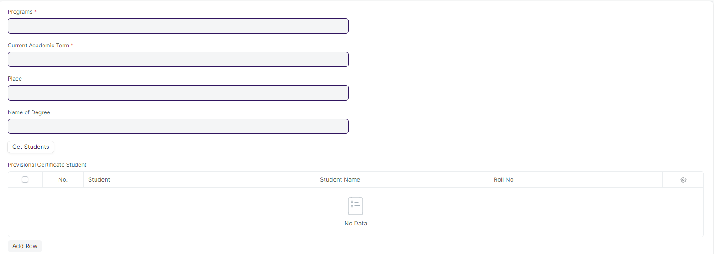

Figure 25 : Provisional Certificate Tool

### **Provisional Certificate Tool Field List:**

The “Provisional Certificate Tool” screen shall consist of the following fields:

|  |  |  |  |  |  |
| --- | --- | --- | --- | --- | --- |
| **Field Label** | **Field Type** | **Validation/Action** | **Mandatory** | **Remarks** | **R/N/D** |
| Programs | Link Field | Fetched from Programs master screen | Y |  | (R) Course |
| Current Academic Term | Link Field | Fetched from Academic Term master screen | Y |  |  |
| Place | Text Field |  |  |  |  |
| Name of Degree | Text Field |  |  |  |  |
| Certificate Creation Status | Dropdown | In Process  Failed  Successful |  |  |  |
| Get Students | Button |  |  |  |  |
| Total Students for Certificate | Number |  |  |  |  |
| **Provisional Certificate Student** | Table |  | Table is describe below |  |  |

|  |  |  |  |  |  |
| --- | --- | --- | --- | --- | --- |
| **Provisional Certificate Student** | | | | | |
| **Field Label** | **Field Type** | **Validation/Action** | **Mandatory** | **Remarks** | **R/N/D** |
| Student | Link Field | Fetched from Get Students Button |  |  |  |
| Student Name | Text Field | Auto fetch based on Student |  |  |  |
| Roll No | Text Field | Auto fetch based on Student |  |  |  |
| Registration Number | Text Field | Auto fetch based on Student |  |  |  |

### **User: Roles & Permission**

The following table describes the users and their roles and permissions for the screens :

|  |  |  |  |  |  |  |  |  |
| --- | --- | --- | --- | --- | --- | --- | --- | --- |
| **Role** | **Select** | **Read** | **Write** | **Create** | **Delete** | **Submit** | **Cancel** | **Amend** |
| Admin | Yes | Yes | Yes | Yes | Yes | NA | NA | NA |
| Instructor | No | Yes | No | No | No | NA | NA | NA |
| Student | No | Yes | No | No | No | NA | NA | NA |

## Migration Certificate

|  |  |
| --- | --- |
| **Description :** | Migration Certificate is a document issued by the concerned University or Board in which one studies. It helps in getting admission to another institution or any education board and it is issued at the completion of the course along with other necessary documents. |
| **Navigation :** | Home > Examination > Transcripts >Migration Certificate |
| **Pre-requisites :** |  |
| **Existing Screen Name :** | Migration Certificate |
| **New Screen Name :** | NA |

### Migration Certificate Screenshot:

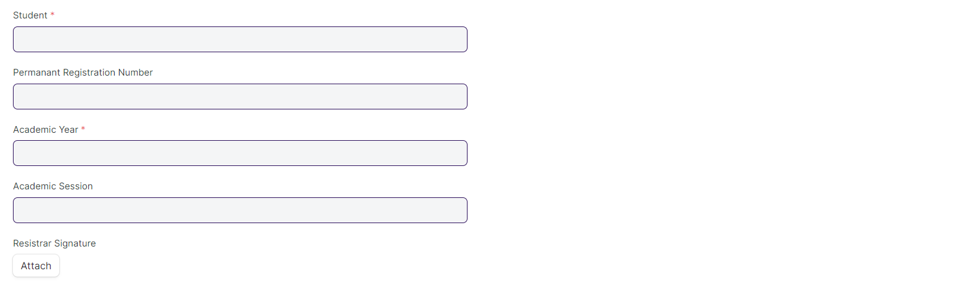

Figure 26 : Migration Certificate Screen

### Migration Certificate Field List:

The “Migration Certificate” screen shall consist of the following fields:

|  |  |  |  |  |  |
| --- | --- | --- | --- | --- | --- |
| **Field Label** | **Field Type** | **Validation/Action** | **Mandatory** | **Remarks** | **R/N/D** |
| Student | Link Field | Fetched from Student master screen | Y |  |  |
| Student Name | Text Field | Auto fetch based on Student |  |  |  |
| Roll No | Text Field | Auto fetch based on Student |  |  |  |
| Permanent Registration Number | Text Field | Auto fetch based on Student |  |  |  |
| Programs | Link Field | Fetched from Programs master screen |  |  |  |
| Academic Year | Link Field | Fetched from Academic Year master screen | Y |  |  |
| Academic Session | Text Field |  |  |  |  |
| Registrar Signature | Attach Image | 1. On attachment a dialogue box will be popup where user can attach the files, take the picture with the help camera and can link any URL. 2. If photos or images attached then the size will be maximum 200 kb. |  |  |  |

### **User: Roles & Permission**

The following table describes the users and their roles and permissions for the screens :

|  |  |  |  |  |  |  |  |  |
| --- | --- | --- | --- | --- | --- | --- | --- | --- |
| **Role** | **Select** | **Read** | **Write** | **Create** | **Delete** | **Submit** | **Cancel** | **Amend** |
| Admin | Yes | Yes | Yes | Yes | Yes | NA | NA | NA |
| Instructor | No | Yes | No | No | No | NA | NA | NA |
| Student | No | Yes | No | No | No | NA | NA | NA |

## Migration Certificate Tool

|  |  |
| --- | --- |
| **Description :** | Migration Certificate is a document issued by the concerned University or Board in which one studies. It helps in getting admission to another institution or any education board and it is issued at the completion of the course along with other necessary documents. |
| **Navigation :** | Home > Examination > Tools > Migration Certificate Tool |
| **Pre-requisites :** |  |
| **Existing Screen Name :** | Migration Certificate Tool |
| **New Screen Name :** | NA |

### Migration Certificate Tool Screenshot :

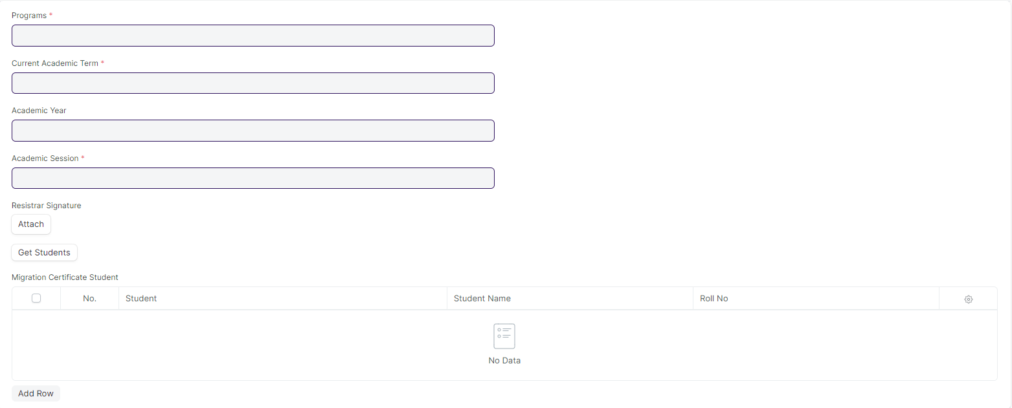

Figure 27 : Migration Certificate Tool Screen

### Migration Certificate Tool Field List:

The “Migration Certificate Tool” screen shall consist of the following fields:

|  |  |  |  |  |  |
| --- | --- | --- | --- | --- | --- |
| **Field Label** | **Field Type** | **Validation/Action** | **Mandatory** | **Remarks** | **R/N/D** |
| Programs | Link Field | Fetched from Programs master screen | Y |  | (R) Courses |
| Current Academic Term | Link Field | Fetched from Academic Term master screen |  |  |  |
| Academic Year | Link Field | Fetched from Academic Year master screen | Y |  |  |
| Registrar Signature | Attach |  |  |  |  |
| Certificate Creation Status | Dropdown | In Process  Failed  Successful |  |  |  |
| Get Students | Button |  |  |  |  |
| Total Students for Certificate | Int | Auto inputted when Get Students button clicked |  |  |  |
| **Migration Certificate Student** | Table | Description of this table is given below |  |  |  |

|  |  |  |  |  |  |
| --- | --- | --- | --- | --- | --- |
| **Migration Certificate Student** | | | | | |
| **Field Label** | **Field Type** | **Validation/Action** | **Mandatory** | **Remarks** | **R/N/D** |
| Student | Link Field | Fetched from Get Students Button |  |  |  |
| Student Name | Text | Auto fetch based on Student |  |  |  |
| Roll No | Text | Auto fetch based on Student |  |  |  |
| Registration Number | Text | Auto fetch based on Student |  |  |  |

### **User: Roles & Permission**

The following table describes the users and their roles and permissions for the screens :

|  |  |  |  |  |  |  |  |  |
| --- | --- | --- | --- | --- | --- | --- | --- | --- |
| **Role** | **Select** | **Read** | **Write** | **Create** | **Delete** | **Submit** | **Cancel** | **Amend** |
| Admin | Yes | Yes | Yes | Yes | Yes | NA | NA | NA |
| Instructor | No | Yes | No | No | No | NA | NA | NA |
| Student | No | Yes | No | No | No | NA | NA | NA |

## Conduct Certificate

|  |  |
| --- | --- |
| **Description :** | A Conduct Certificate specifies the behavior of an individual during a period of time, in an official place. It is also sometimes referred to as a character certificate. A conduct certificate is given to a student when he wants to get admission in another institute or in case of transfer. |
| **Navigation :** | Home > Examination > Transcripts > Conduct Certificate |
| **Pre-requisites :** |  |
| **Existing Screen Name :** | Conduct Certificate |
| **New Screen Name :** | NA |

### Conduct Certificate Screenshot :

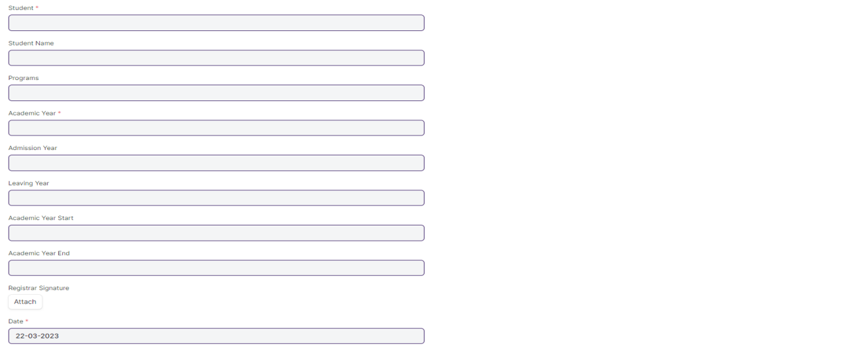

Figure 28 : Conduct Certificate Screen

### Conduct Certificate Field List:

The “Conduct Certificate” screen shall consist of the following fields:

|  |  |  |  |  |  |
| --- | --- | --- | --- | --- | --- |
| **Field Label** | **Field Type** | **Validation/Action** | **Mandatory** | **Remarks** | **R/N/D** |
| Student | Link Field | Fetched from Student master screen | Y |  |  |
| Student Name | Text Field | Auto fetch based on Student |  |  |  |
| Roll No | Text Field | Auto fetch based on Student |  |  |  |
| Programs | Link Field | Fetched from Programs master screen |  |  | (R) Courses |
| Academic Year | Link Field | Fetched from Academic Year master screen | Y |  |  |
| Admission Year | Text Field |  |  |  |  |
| Leaving Year | Text Field |  |  |  |  |
| Academic Year Start | Date Picker |  |  |  |  |
| Academic Year End | Date Picker |  |  |  |  |
| Registrar Signature | Attach Image | 1. On attachment a dialogue box will be popup where user can attach the files, take the picture with the help camera and can link any URL. 2. If photos or images attached then the size will be maximum 200 kb. |  |  |  |
| Date | Date | Today’s date is fetched | Y |  |  |

### **User: Roles & Permission**

The following table describes the users and their roles and permissions for the screens :

|  |  |  |  |  |  |  |  |  |
| --- | --- | --- | --- | --- | --- | --- | --- | --- |
| **Role** | **Select** | **Read** | **Write** | **Create** | **Delete** | **Submit** | **Cancel** | **Amend** |
| Admin | Yes | Yes | Yes | Yes | Yes | NA | NA | NA |
| Instructor | No | Yes | No | No | No | NA | NA | NA |
| Student | No | Yes | No | No | No | NA | NA | NA |

## Conduct Certificate Tool

|  |  |
| --- | --- |
| **Description :** | A Conduct Certificate specifies the behavior of an individual during a period of time, in an official place. It is also sometimes referred to as a character certificate. A conduct certificate is given to a student when he wants to get admission in another institute or in case of transfer. |
| **Navigation :** | Home > Examination > Tools > Conduct Certificate Tool |
| **Pre-requisites :** |  |
| **Existing Screen Name :** | Conduct Certificate Tool |
| **New Screen Name :** | NA |

### Conduct Certificate Tool Screenshot :

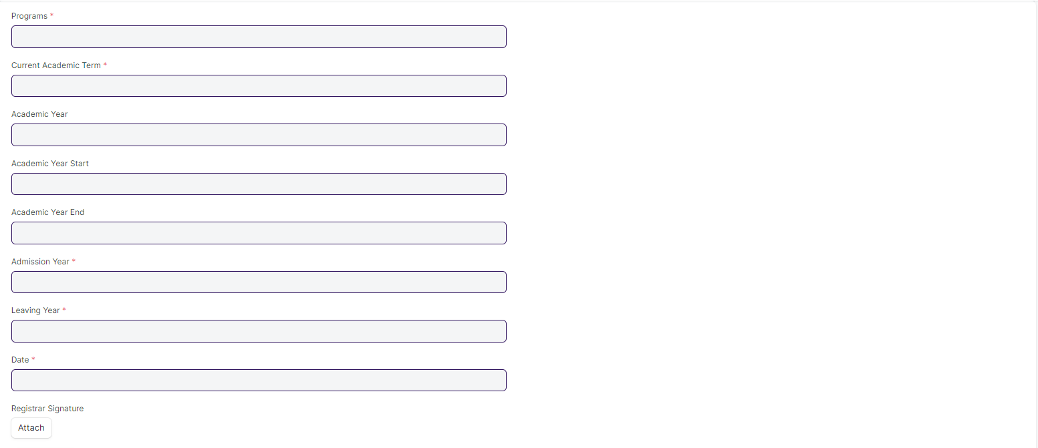

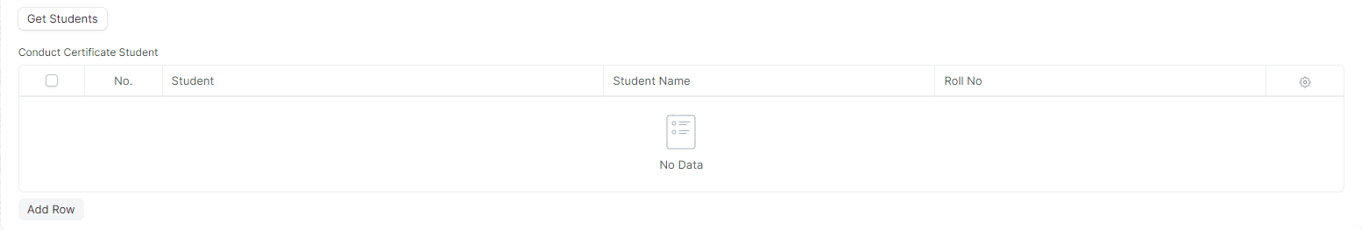

Figure 29 : Conduct Certificate Tool Screen

### Conduct Certificate Tool Field List:

The “Conduct Certificate Tool” screen shall consist of the following fields:

|  |  |  |  |  |  |
| --- | --- | --- | --- | --- | --- |
| **Field Label** | **Field Type** | **Validation/Action** | **Mandatory** | **Remarks** | **R/N/D** |
| Programs | Link Field | Fetched from Programs master screen | Y |  | (R) Courses |
| Current Academic Term | Link Field | Fetched from Academic Term master screen | Y |  |  |
| Academic Year | Link Field | Fetched from Academic Year master screen |  |  |  |
| Academic Year Start | Text |  |  |  |  |
| Academic Year End | Date |  |  |  |  |
| Admission Year | Text |  | Y |  |  |
| Leaving Year | Text |  | Y |  |  |
| Date | Date |  | Y |  |  |
| Registrar Signature | Attach |  |  |  |  |
| Certificate Creation Status | Dropdown | In Process  Failed  Successful |  |  |  |
| Get Students | Button |  |  |  |  |
| Total Students for Certificate | Number | Auto inputted when Get Students button clicked |  |  |  |
| **Conduct Certificate Student** | Table |  |  | Table is describe below |  |

|  |  |  |  |  |  |
| --- | --- | --- | --- | --- | --- |
| **Conduct Certificate Student** | | | | | |
| **Field Label** | **Field Type** | **Validation/Action** | **Mandatory** | **Remarks** | **R/N/D** |
| Student | Link Field | Fetched from Get Students Button |  |  |  |
| Student Name | Text | Auto fetch based on Student |  |  |  |
| Roll No | Text | Auto fetch based on Student |  |  |  |
| Registration Number | Text | Auto fetch based on Student |  |  |  |

### **User: Roles & Permission**

The following table describes the users and their roles and permissions for the screens :

|  |  |  |  |  |  |  |  |  |
| --- | --- | --- | --- | --- | --- | --- | --- | --- |
| **Role** | **Select** | **Read** | **Write** | **Create** | **Delete** | **Submit** | **Cancel** | **Amend** |
| Admin | Yes | Yes | Yes | Yes | Yes | NA | NA | NA |
| Instructor | No | Yes | No | No | No | NA | NA | NA |
| Student | No | Yes | No | No | No | NA | NA | NA |